INFO 4 Coursework booklet

Home Start South Derbyshire Solution

De Ferrers Academy

Robert Pott

Contents

SECTION 1 - Background 2

1.1 Background and Investigation of Home Start South Derbyshire 2

1.2 Current Home Start Systems 5

1.3 Client User & Audience 7

1.4 Justification of Solution 7

1.5 Research Methodology 9

1.6 Research Material 11

1.7 Research Analysis 22

1.8 User Requirements 29

SECTION 2 - Analysis 33

2.1 Problem Statement and Scope 33

2.2 Proposed System 38

2.3 System Processes 43

2.4 User Skills 46

2.5 Evaluation Criteria 49

SECTION 3 - Designs 52

3.1 Solution Designs 52

3.2 Test Strategy 56

SECTION 4 – Testing 57

4.1 Functional Test Plan (Next Page) 57

4.2 Environment & End-User Testing Plan 75

Evaluation 80

# SECTION 1 - Background

### 1.1 Background and Investigation of Home Start South Derbyshire

The business that I have chosen to be my client for this project is Home Start South Derbyshire. Located in Newhall, Southern Derbyshire, it is a non-profit organisation dedicated to providing aid and support for struggling families in the area. My client is part of the larger charity of Home Start UK as a branch local to southern Derbyshire, but acts mostly independent of the parent organisation. This includes having to completely handle funding themselves, meaning they rely heavily upon donations and fundraising projects to continue. Home Start UK has a total of 251 branches across the UK and as an organisation, its fundamental purpose is to provide support for families struggling for various reasons with young children (At least one child of 5 years or younger). These reasons can be simple such as parents struggling to cope and financial difficulty, all the way up to disabilities, illness and mental health issues. Home Start always operates all-year round to provide top quality support to vulnerable families, but relies heavily on volunteers who are trained continually to provide needed aid to families, operating only on weekdays and primarily during school hours, as they target parents and young children. Home Start also typically operates within the homes of families they help, so that they can provide the most flexible aid possible. The primary ways in which families discover and get in touch with Home Start is typically through a referral from a specialist or online. The digital platforms through which Home Start operates includes both social media and a dedicated website. The social media (Facebook and Twitter) is mainly used for sharing information and some communications with volunteers and families. The website for Home Start however, plays a larger role as it is a large resource of information on Home Start South Derbyshire, useful to potential volunteers and new families. As such it is crucial that it is deemed acceptable by its audience, due to its use as a resource of materials such as volunteer application forms and contact details for Home Start. As it currently stands, Home Start South Derbyshire has deemed its current website inadequate for their purposes and have come forth and presented this issue to me, so that I may produce a solution.

Looking at the history of Home Start UK, it was originally founded in 1973 in Leicester by Margaret Harrison who upheld a belief that supporting a family was best done in their home to shape it best to the given need. Eventually Home Start began to spread across the UK opening more and more branches. In 1984, the South Derbyshire branch for Home Start was established for helping the struggling families in the area. It has still expanded to this day, currently operating within 22 countries over 5 different continents. Based on the historical information stated, it is clear that Home Start is a large scale organisation as it operates globally. However, my client is the branch from South Derbyshire and as such the scope for the branch is the area of that county in the UK. The branch only has a single building to operate from, the office located in Newhall as they deliver their support work in the homes of the families they provide aid to.

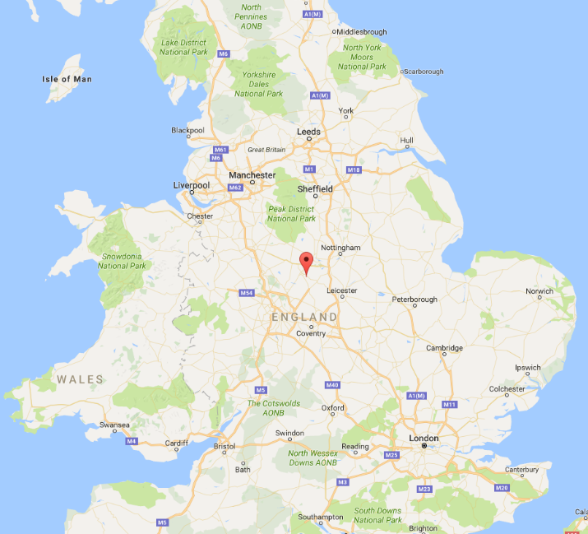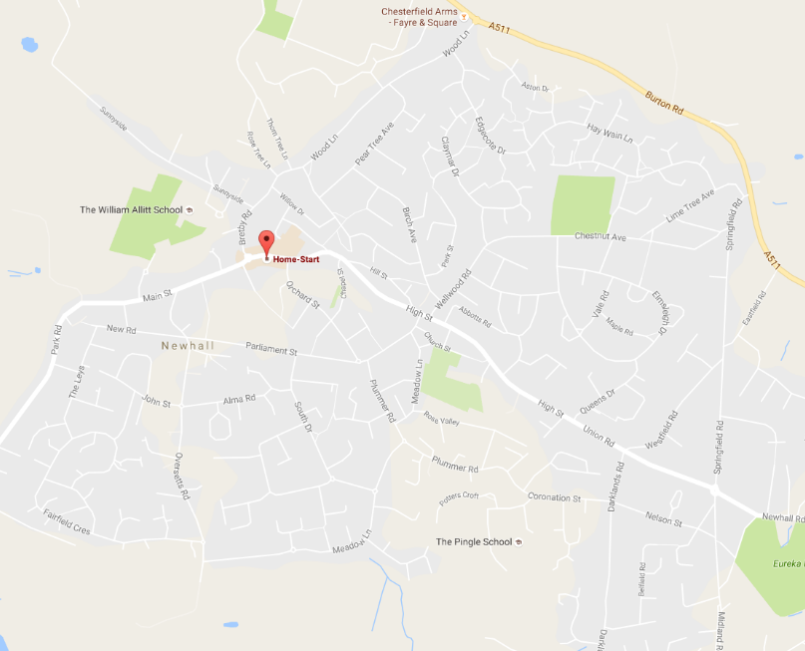

Figure 1: Location of Home Start South Derbyshire in Newhall

Figure 1: Location of Newhall within the UK

Although the branch of Home Start South Derbyshire is small, it still has a variety of roles within it and a set hierarchy. The structure is mapped out as such:

**BOARD OF TRUSTEES**

Treasurer, Policies & Procedures, Training & HR, Funding, Corporate Relationship & Staff Liaison, Advisor to Trustees

**SENIOR Co-ordinator**

**P/T Co-ordinator**

**Volunteers &**

**Families**

The board of trustees are the group of people with leading roles within the organisation, handling tasks of great importance. For example, the treasurer is in charge of handling the majority of the finances for the organisation, whilst the trustee for funding handles schemes to fund Home Start through various means. However, it is most important that the board of trustees can cooperate to fully coordinate the management of Home Start so that everything runs smoothly. An example would be how the treasurer and trustee of funding would need to communicate a large amount as the latter handles the majority of income for Home Start. Thus, planning financial schemes would be done with at least the two of them in such circumstances.

Below the board of trustees is the senior co-ordinator of Home Start, Tracey Harris. Their role in the organisation is to oversee the coordination of the volunteers and the families but also work with the board of trustees. This would entail taking advice, schemes and plans from the board and putting them into practice with the roles below theirs.

Next down is the P/T co-ordinator, Katrina Lee. Their role is to directly manage the volunteers and families involved with Home Start. This role ranges from accepting volunteer applications and consulting with the senior co-ordinator over them, to handling which volunteer should go where. They will have to get in touch with specialists who may have referred families to Home Start or families that have found them through other means and manage how to handle their situation. This will entail organising dates and times for support for families and which volunteers should help.

Lastly, the volunteers and families are the groups managed by roles above them. The volunteers for Home Start are people accepted after applying to work with the organisation as support workers for families. They will have undergone a minimum of several weeks’ worth of specialised training for their role and are assigned to families at designated times when most suitable, as Home Start also takes into account the volunteers themselves when they assign them for more flexible and comfortable support. Meanwhile, the families are the people eligible to receive support from Home Start and have come forth to them. These people are the ones who receive co-ordinated support from Home Start that should meet their needs.

### 1.2 Current Home Start Systems

The current system that Home Start wishes to be replaced by me is their website that is used as a marketing and information resource. This is site is mainly dedicated to introducing new families and potential volunteers to the organisation and providing them with further information. At the top of the website, there is a navigation bar, which is used to access the majority of the site and its resources. Currently, the website is maintained by a third party who handles all of the site’s maintenance.

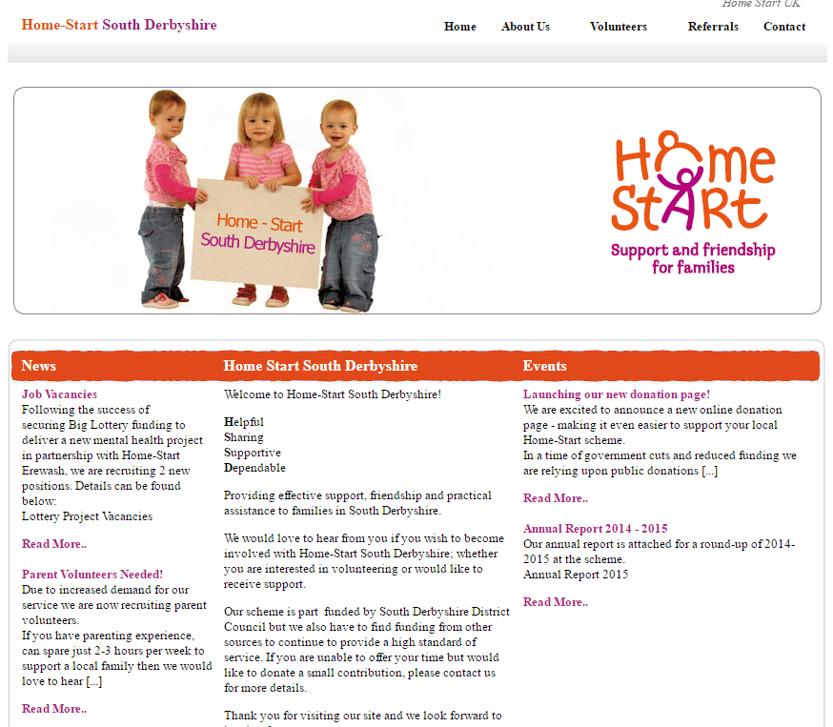The primary purpose for this website as previously stated is to act as an information resource. However, this purpose can vary depending upon who is using the site as there are different audience groups for the website. The first of which is families, who will mainly use the site to look up details about the organisation if they have been referred to it or discovered it via other means. They would also then use it to access contact details for Home Start, so that they may get in touch to get help. The second audience group would be the potential volunteers for the organisation, who in a similar fashion to families would look up details about Home Start on the website and their contact details. However, volunteers would also use the site to access the information and files explicitly focused on volunteers. The final main group would be funders, who would want to look up any information on the organisation to decide if they are worthy of receiving funding from them.

The website itself appears as it does to the right. The most notable features of the site are that there is a navigation bar at the top of the page. Hovering over each option on the navigation bar can cause a small drop down menu to appear for accessing more specific pages. It must me noted that against common website design conventions, the logo for Home Start is not at the top of the page. It is instead, located alongside the image reel. In the corner where a logo would commonly be 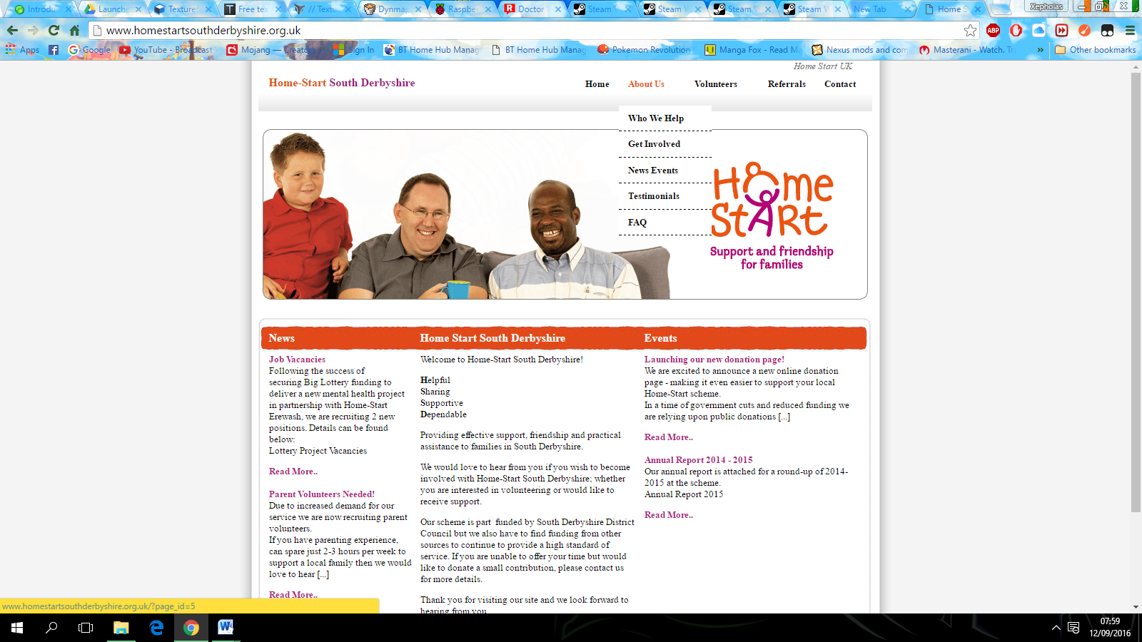located, there is merely text in the same font and size of other headers on the page. As for the rest of the page, it is a simple article-like layout with information such as news and events. Other pages can follow a similar format in terms of how the text is placed in a box with an orange header bar. On most other pages, there is supposed to be a comments system, however they are always closed on every page. At the top right hand corner of the page, there is a tiny link that takes you to the home page of Home Start UK’s website.

As gathered in the website description, there exist a large variety of design and use issues with the current website. They are as follows:

* Focusing on the logo, having the logo located where it is in the middle of the page looks nice, but what replaces it in the top right hand corner looks basic and unprofessional as it looks as though no effort was made to even change the font to better stylise the text due to it sharing the same font and size as the headers except in colour for the house theme.
* Next, the link for the Home Start UK website in the top left corner is barely visible and almost looks as if it isn’t a link. Something of the sort would be better placed in the footer of the page, with other references.
* The overall house theme for the website does match up with the colours of the Home Start logo, but their use feels severely limited. This combined with most of pages comprising of text, makes them look very bland and uninteresting, which could potentially turn people away from the site due to how unprofessional it looks at times.
* One more subject to focus on is the lack of the comments system. It seems that it was to be implemented so that visitors to pages can make feedback on their contents, but it never was, making one question why it is still left their in the first place.
* An issue directly provided by my client is that accessing files for volunteer documents on the website is confusing and has turned away potential volunteers in the past before. This is because when one clicks on a link to download a file, it first redirects one to a separate pointless page with the actual download link. This has confused many into thinking that the downloads do not even work.
* Another issue provided is related to the current third-party managing the site. My client stated to me that they charge money (£40-£60) to update the website, even to simply add a single image, which she has been trying to do for some time now.

The system that the website itself is a part of is a typical system for families and volunteers getting in touch with Home Start and then getting involved. Firstly, users to the site will have initially discovered it through means such as a referral, searching by service, social media, word of mouth, etc. [1] From this, people on the site can use it to read information for what fits their intended purpose for the visit to the site. At this point a potential family client would read things such as offered services, whilst volunteers would read that and extended information on volunteering. [2] From this, both parties would use the resources to get in touch with Home Start to organise anything necessary. [3] Further materials must then be obtained from the website for applications for both families and volunteers so 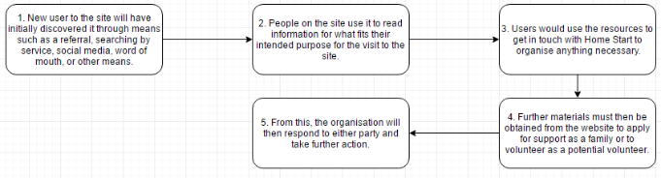either party can use them to apply. [4] From this, the organisation will then respond to either party and take further action. [5]

### 1.3 Client User & Audience

The client for this project is the senior co-ordinator of Home Start, Tracey Harris, who has contacted me for help with replacing the current website used by Home Start South Derbyshire, as they deem it outdated and inadequate. To go into greater detail, the current website in place was produced several years ago and has not been updated much since then and as such, looks quite outdated style-wise. There are certain non-functional features on the website too, such as the comment system alongside page navigation being awkward and confusing, turning away potential volunteers from the organisation. It also currently stands that the website is quite restricted and costly (Taking a large amount to simply add even images). Thus, believing that the site is beginning to negatively impact Home Start, I have been requested by this client to provide a suitable solution to this issue.

The website for Home Start would have limited users to it, with the main being the client and some board of trustees members. This is because, they would use it to update and change information and other features on the website over time. However, the volunteers can also be users of the website as they will need to navigate across the site to access application forms for becoming a volunteer at Home Start. Similarly, families can also be considered users due to how they would access the site to get in touch with Home Start and perhaps applying for support through the site.

The primary targeted audience of the Home Start website would be families (As they can read about them and get in touch), potential volunteers (who can read and research about volunteering) and funders (who can read information about Home Start to perhaps encourage them to provide funding). The main three are targeted based on importance and relevance to the organisation and as such, information is augmented and made most suitable to these groups. However other audiences for the website can include councils looking up the charities in the area and existing Home Start volunteers who may need to access information from the website. The general public can also be seen as an audience, in which the purpose of the site is to educate people about what the organisation is and its line of work.

### 1.4 Justification of Solution

When I decided to accept the job of producing a solution for my client, I was presented with the issues currently affecting Home Start with their existing website:

* The website is outdated and is inadequate for advertising.
* Confusing layout and navigation has turned people away from the organisation.
* The current website is difficult to update as it has to be done through a third party and costs a large amount of money, meaning it is hardly updated.
* After investigating, hiring a professional to redesign the current website is too expensive as they are limited in finances as a local charity branch.

From being presented with these issues by my client Tracey Harris, I am to produce a new website as a solution to all of the problems that they are experiencing with the existing system. As such, the project has a core focus of tackling these issues as an update to the existing site. To expand upon the first issue, the current website in place is very basic in design, but follows a house theme that matches the Home Start logo in colours. However, its overall layout is nearly the same for every page and looks very dull and boring. This adds up to make the site look very unprofessional and completely inadequate for advertising as it looks visually unappealing. As such, the solution I produce must surpass the current one by using an innovative design that follows the house theme and acts as an excellent medium for advertising the charity to the public online. My solution will primarily have to carry this out with a sleek design that looks modern and has a layout that draws interest to the content (e.g. Articles with preview images, better text and image layout, etc.).

Focusing on the second given issue, the current website has a navigation system for files that confuses people who want to access them. Currently, if you were to click the download link it takes you to an extra, pointless page with a less conspicuous download link. According to my client this has confused and angered a lot of people in the past and has turned many people away from it. Based on this, I need to produce a solution for Home Start that has easy to understand navigation and accessible downloads, so that there is no longer any confusion surrounding it. I will carry this out by having a solution with a simple navigation bar with downloads clearly labelled. Individual download links will no longer have to take a user to another page and will instead instantly start the download.

The third issue was the largest issue put forwards to me by my client as the current website’s setup makes her incapable of updating the website as it is carried out by the third party that manages the site and they charge around £50-60 for any updates. This can include how she simply wanted to add a new image to the site recently, but was presented with the same fee. She also is unable to add updated content to the site. Looking at this, I will have to make my solution easy to update with little hassle, so she can carry it out herself, at her own pace. This will ensure steady updates that can be bespoke and carried out at any time. This will add work on my end as an interface for updates will be needed and training for my client will be needed too. However, I will not charge any money for this, as I want to make the procedure for updates self-sufficient.

The last presented issue is that

The last presented issue is that Home Start cannot afford the prices from professionals for this job, so they have turned to me, who will accept experience as my payment. I feel that this is one of the most compelling reasons to produce my solutions as I have been provided information on this topic by my client, and the prices for the scale of the site are absurd. As such, I feel it is a necessity that I produce my solution for Home Start, as a charity organisation shouldn’t have to fret over the finances of its website so much.

### 1.5 Research Methodology

Over the coming months, I plan to perform extensive research into the system that I will be replacing and the requirements from my client. Adopting the most suitable approach in advanced is key, in order to be able to produce a successful full-scaled analysis from which I can plan out my solution. Thus, it is required to select my methods of research beforehand. It must be noted that this research will entirely be primary research as I have no plans to use second hand research materials, primarily as there aren’t many available. For this research I have ultimately chosen to carry out a combination of Questionnaires, Interviews and Document Analysis. This is because, taking into account the nature of the business, the availability of research sources and material to research, these methods work best. Building upon this, a document analysis is highly suitable due to the easy access to the vast array of the materials that the system comprises of. As for Interviews, it is most suitable due to the limited number of system users I can communicate with and ease of communications with the business. The Questionnaires can be used to collect quantitative data from the targeted audience of the system, to gather general data on things such as weak points in the system. These can combine to produce a thorough analysis of all parts of the systems and processes, as the methods will allow me to collect information from a variety of perspectives and materials that allow me to reinforce the user requirements for this project with a strong conclusion.

**Questionnaire**

My first method for research that I will carry out are questionnaires that will be done with the audience for the Home Start website. I have chosen to use them in this circumstance to gauge opinions about the current website as quantitative data. I have decided that this is suitable, so that I can sample information from the wider audience of the website and collate it into statistics for further analysis. I will carry this out by providing a set questionnaire that focuses on quantitative results to people who have used the current Home Start website for different purposes. I will include extensive questions to ask about intentions of users and how they found the current site. I will then use this data and produce summaries and graphs for further analysis of the website.

**Interviews**

The second method of research that I plan to carry out will be interviews with the Senior Co-ordinator of Home Start about the systems used there and what they want to change. I have chosen to use an interview over a questionnaire here, because the system used there primarily has only a single user, making interviews more suitable as they are more thorough. For the interviews, they will be carried out with Tracey, the primary user of the current system I am analysing and replacing. The small sample is suitable as interviews can take up a lot of time in exchange for thoroughness and doing a larger sample with customers (the audience for a system) is out of the question as the main users are great in number but not easily available to question due to their busy schedules. These interviews can be carried out on site if a visit is possible, with the business not typically affecting the sampling time as it can be done anytime. However, they can be performed through use of other communication means if I am unable to visit the business. This can include the use of telephones or video conferencing.

**Document Analysis**

The third and final method of research that I will be using at Home Start is a document analysis. This will be where, in my own time I take existing documents with any ties to the systems and analyse them in detail. This analysis will mainly revolve around taking sample images of the documents and materials, and annotating details that are visible or I am aware of. I have chosen to carry this out as a part of my research as it is suitable in the given context. The system that I am to analyse and replace had a number of files and documents used for it and as such, a detailed analysis of each part will allow for a deeper understanding of the system and how to improve it. Only I have to be involved with this research; however I will need permission from Tracey who is in charge of the system in this project, due to information that may be deemed inappropriate for use in analysis. As for carrying this out, I’ll be checking what documents the systems are comprised of in advance and then taking images of it all and annotating the different parts of it. The further analysis will come at a later point when I analyse all of my research as one. In regards to when and where this can be done, there is virtually no limit as my client can send me copies of the documents via the Internet if needed. However, this could pose the risk that the documents are stolen, so taking the documents in person may be better.

**Conclusion**

Following up from the individual pieces of research, I will have to collate the information and produce a detailed analysis for each task that must be performed differently. For the questionnaire, I will take the raw data and process it into useful information such as graphs. I will then compile this with more qualitative data to form an extensive report analysing the results of the user questionnaires. As for the interviews, I will take the written notes/transcript to produce a final summary of the key points drawn from both interviews for use in any further analysis. For the document analysis, I will take the annotated information and collate it to produce a detailed report analysing the different systems and sums up the key points.

A fair amount of the data that will be collected by this research will be qualitative, so with all tasks they must be analysed by taking out the key points that are relevant, whilst the quantitative data can easily be sorted and analysed. Once all three parts of the research have been brought together and been subjected to basic analysis, I will produce an extensive report that links together each piece of research and allow me to conclude what my user requirements for this project ultimately are. This is done through sorting out the key points of the information and ranking their importance based off the frequency of their occurrence throughout the entire research.

### 1.6 Research Material

# Interview Notes for Home Start South Derbyshire

|  |
| --- |
| Interview Details |
| |  |  |  |  |  |  | | --- | --- | --- | --- | --- | --- | | Company Name: | Home Start South Derbyshire | Date: |  | Time: |  | |
| |  |  | | --- | --- | | Interviewer Name: | Robert Pott | |
| |  |  |  |  | | --- | --- | --- | --- | | Interviewee Name: | Tracey Harris | Interviewer Phone Number: | (07532399139) | |
| |  |  | | --- | --- | | Topic for Interview: | Website for Home Start South Derbyshire | |

|  |
| --- |
| Questions to Ask Interviewee |
| |  |  | | --- | --- | | Question: | How often do you use the website and what for? | | Notes: |  | |  |  | |  |  | |  |  | | Question: | Does anyone else besides yourself use the system? | | Notes: |  | |  |  | |  |  | |  |  | | Question: | How often do you encounter issues with the website, if so please specify. | | Notes: |  | |  |  | |  |  | |  |  | |  |  | |  |  | |  |  | |

|  |  |
| --- | --- |
| Question: | How do you deal with any issues in the system if there are any? |
| Notes: |  |
|  |  |
|  |  |
|  |  |
|  |  |
|  |  |

|  |  |
| --- | --- |
| Question: | How secure is the current system? Security, backups, location, file organisation, physical/digital? |
| Notes: |  |
|  |  |
|  |  |
|  |  |
|  |  |
|  |  |
|  |  |
|  |  |
|  |  |
|  |  |

|  |  |
| --- | --- |
| Question: | How would you improve this? |
| Notes: |  |
|  |  |
|  |  |
|  |  |
|  |  |
|  |  |
|  |  |
|  |  |
|  |  |

|  |  |
| --- | --- |
| Question: | Describe how the different audiences would need to go about using the website. |
| Notes: |  |
|  |  |
|  |  |
|  |  |
|  |  |
|  |  |
|  |  |
|  |  |
|  |  |
|  |  |
|  |  |
|  |  |
|  |  |
|  |  |
|  |  |
|  |  |
|  |  |

|  |  |
| --- | --- |
| Question: | Would this present any issues in categories such as design? How would you want them fixed? |
| Notes: |  |
|  |  |
|  |  |
|  |  |
|  |  |
|  |  |
|  |  |
|  |  |
|  |  |
|  |  |
|  |  |
|  |  |
|  |  |

|  |  |
| --- | --- |
| Question: | Overall, what would you want improving about the website? |
| Notes: |  |
|  |  |
|  |  |
|  |  |
|  |  |
|  |  |
|  |  |
|  |  |
|  |  |
|  |  |
|  |  |
|  |  |
|  |  |
|  |  |
|  |  |

|  |
| --- |
| Additional Notes |
|  |
|  |
|  |
|  |
|  |
|  |
|  |
|  |
|  |
|  |
|  |
|  |
|  |
|  |
|  |
|  |
|  |
|  |
|  |
|  |

**Questionnaire Sample:**

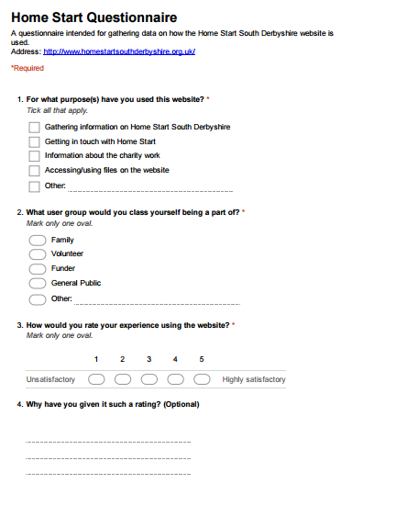

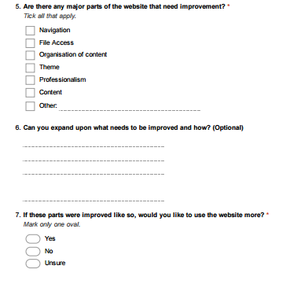

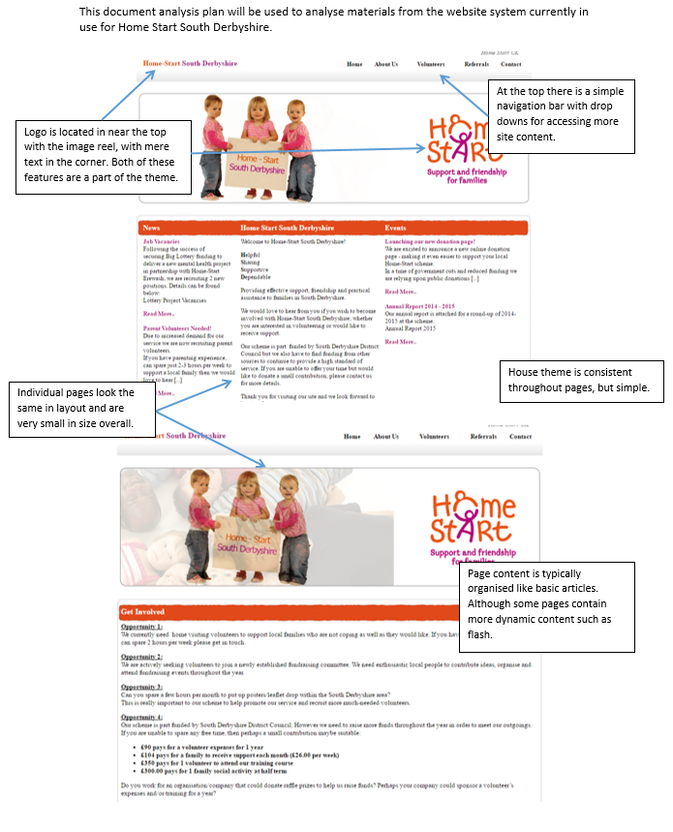**Document Analysis**

### 

### 1.7 Research Analysis

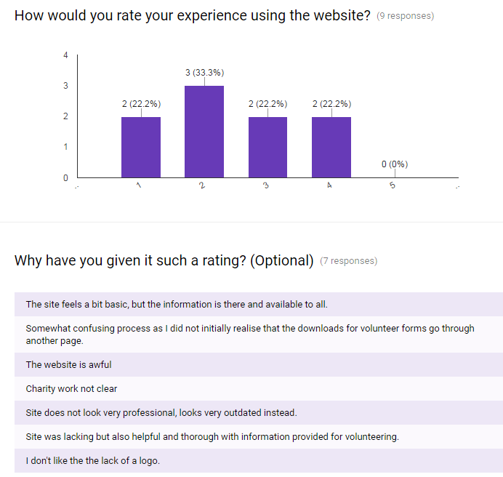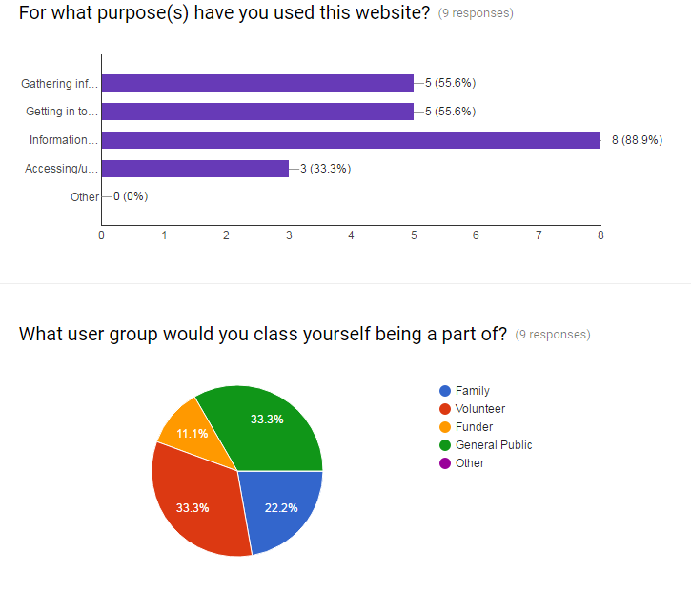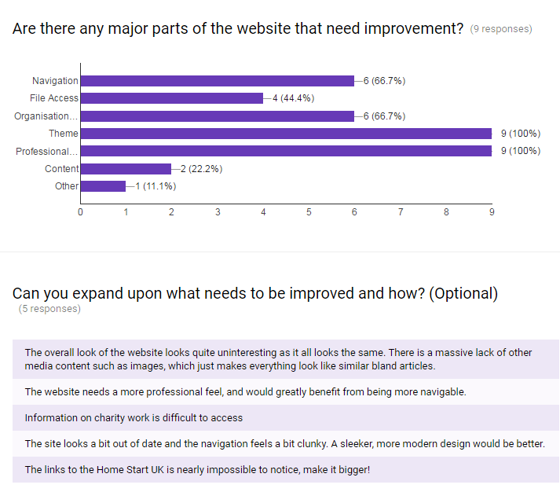Over the course of the recent weeks, I have designed and carried out a variety of methods of research into the current website used by Home Start South Derbyshire. As planned, I carried out a questionnaire, an interview and a document analysis to gather a wide variety of data to use for extensive analysis, in order to gain a deep understanding of what needs to be done for my final solution. The first piece of research that I will look into is the questionnaire carried out on people who have used the website for different purposes. This was to gain a better understanding of who responses and expand upon what they provide and also trends that can be spotted. The questions and results of the questionnaire are below in 4 chronological sections:

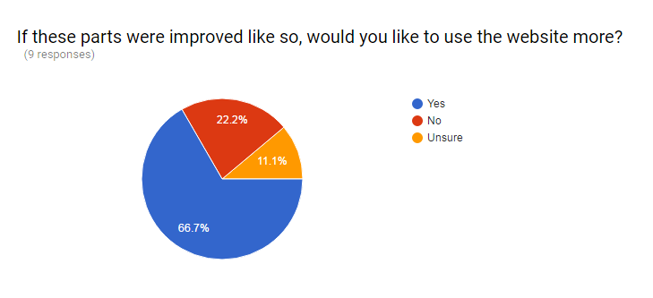**SECTION 1**

**SECTION 3**

**SECTION 4**

**SECTION 2**

**SECTION 1**

The first portion of the questionnaire asked people for what purpose they had used the site and what user group they are classed under. The questions asked here were used to gauge the primary uses for the Home Start website, revealing an overall majority of 88.9% for “Information on charity work”. The other majority was “Getting in touch with Home Start” and “Gathering info” at 55.6%. The lowest was “Accessing/using files” at 33.3%, but all of this data tells me that using the website as an information resource is its most popular usage, supported by the next set of data. The data that follows this is the user groups, in which people were asked to define what user group they would be under. Accordingly, the data shows that the top site users match up with previous projections, which were that the main users would be families, volunteers and other people. The value for funders was much lower, however it is likely not as frequent that a funder would visit the site compared to others. Looking further into what all of this data means, it tells me the basis of how I need to design the new website for Home Start. This is because it clearly shows who wants to use the site and what for, thus I can take into consideration these key points when producing the designs for my final product so it is best suited to its audiences as a bespoke solution. For example, during the design phase, I’ll need to make it suitable for the target audiences but also user friendly enough to new users and particularly the general public. And I would also need to put varying levels of focus on ensuring the user needs are met according to the different uses that I have researched.

**SECTION 2**

This section of the questionnaire was a section aimed at obtaining qualitative data, even if it is small in quantity as it is useful to have a mix of data. This was essentially a two part question asking users to rate the website and then explain why they did so. Not all users provided feedback to the second question, but some data was still obtained. Looking into the data now, there is a clear trend showing that users do not rate the website well, with a rating of 2 (On a scale of 1-5) being the most selected choice at 33.3% and 0% for a rating 5. This clearly indicates a trend of negative opinions across all users for the site as most demonstrate dissatisfaction for it in the data. This is where the second question is most important as it provides sampled opinions of pros and cons of the current website.

The data for the second question correlates with the first one as in summary, most reasons contain negative views. Some of these responses are quite useful, providing some insightful opinions on issues with the site and what is fine as it is. Whilst on the other hand, responses such as “The website is awful” are too vague. However, the general pattern across the responses shows that the majority of users find the information and content and website acceptable. The layout and design though is a different story. The responses go into detail stating that the organisation makes the site difficult to use at time and that it looks outdated and unprofessional (such as the logo not in the corner). Overall, this data is extremely useful, as I have been given tips on what to change and leave the same (even if just by a bit) by the users themselves, so I can formulate key system requirements for designs in the future according to some of this data.

**SECTION 3**

The third section of the questionnaire that I created was made to add on to the previous section by asking users what key areas of the website need improving and why. Same as the last section, the second question was optional and as such does not have as many responses due to them being qualitative. This is quite similar to the previous question asking why users liked the site or not, except this one asks about how to improve it. And from it, there is a clear trend of what the users want to see improved in the system. The main two improvements wanted to the site are professional design and theme with a vote 100%. This indicates a strong opinion, demonstrating previous views that the design and layout for the website is unsatisfactory. This is backed up further by the next data along, a 66.7% vote for both navigation and organisation being improved, which were also compained about. As such, this data is a highly important reference for the design phase as it indicates what I need to focus on most during the creation of a new website.

The second question asks for more details on improving the current website in detail and it seem to vary, but nonetheless it matches previous data as most responses involve the design and organisation of the website. This is now a key point to focus on during designs now as all of this data has pointed to towards a focus on better page design. Other things mentioned here should be focused on too as they are all responses worthy of being used in designs.

**SECTION 4**

The fourth and final section comprises of a single question for collecting quantitative data from users. Following all previous questions on improving the website, it asks whether or not they think that they’d be willing to use the website more if the improvements were implemented. This is very useful as it gives me an idea of how serious the users are about their responses. From this, most said yes, meaning that I should closely follow their responses when considering website designs to meet the specifications of my users much better with the final product.

**CONCLUSION**

Overall, to look at all of the data before me, clear trends have arisen. It is strongly evident who my main users/audience for this website are and what they would expect from it. Having looked through the entirety of this data and extracting key information, the most notable point from this research is that the website’s audience is strongly opposed to the current design and layout of the current Home Start website as shown by the variety of both quantitative and qualitative data identifying issues with it and suggesting solutions. From this, I believe it is best to set website design as high priority.

**INTERVIEW**

The second piece of research that I carried out was an interview with my client Tracey Harris, in which I asked a serious of questions and noted down key points from her responses, so sifting through a transcript would not be needed. The questions asked and the summarised key points of her responses are below:

How often do you use the website and what for?

* Tracey stated that she does not access the site often.
* She said it was due to the limitations of access, where she can’t update the site with information without paying.
* This means not even news is updated, having to post on alternatives like social media instead.
* She said that if she could update the site, she would do so on a regular basis to promote Home Start and its scheme.

Does anyone else besides yourself use the system?

* Met with a simple response, Tracey said that only she uses the website and associated materials from within Home Start South Derbyshire.
* This makes her the primary user of the website.

How often do you encounter issues with the website, if so please specify.

* She was unable to identify any issues under this category.
* However, she did go back and reiterate the point of how accessing the documents on the current website is confusing and has turned people away.

How do you deal with any issues in the system if there are any?

* No applicable response was available for this question to due to the previous one.

How secure is the current system? Security, backups, location, file organisation, physical/digital?

* When asked about backups, Tracey stated that it is unknown whether or not the website itself is backed up, meaning that in the event of a disaster such as a system crash, the site could be lost altogether.
* There seems to be an evident lack of communication between Tracey and the current website host.
* The files on the website are backed up by Tracey.
* The website also does have a password system protecting, although where it is was not specified.

How would you improve this?

* Not much could be thought for this question, but Tracey suggested preparing a website backup out of concern for a total loss of the website with no up to date content backed up either.

Describe how the different audiences would need to go about using the website.

* I had asked Tracey this previously, but now for confirmation on her part.
* Volunteers => Paper work
* Agencies => Referral forms
* Funders => Annual report
* New information from this is highly important as I had missed the inclusion of agencies from my planning alongside the documentation.

Would this present any issues in categories such as design? How would you want them fixed?

* The current website is not user friendly when considering the audience and their requirements.
* In terms of being more specific, Tracey told me some new info that agencies also have issues with the current website like volunteers as many have been confused about accessing files from the website.

Overall, what would you want improving about the website?

* Tracey specified that she mainly wants the layout of the site to be updated so it looks more visually appealing and isn’t as confusing.
* She would also want there to be links to the Home Start social media.
* She ended by saying that she’d want the website to be “revitalised”.

**Conclusion**

From looking at the responses from my interview, I can see that Tracey primarily wants a focus on the updating and rejuvenation of their website. However, she has shown that she wants the new website to be dynamic and easy to use so that she can regularly update it. As such, I should put a focus towards making it suitable to her expectations alongside making it match the purposes of the various audiences too. Security seems to be of little concern but I now know that I must take it into account so Tracey can trust the new site, with passwords and content backups. In a similar fashion to previous research though, my main focus that I should be targeting is the design of the new Home Start website as neither my client nor the site’s audience are satisfied with the current one.

**DOCUMENT ANALYSIS**

The third and final piece of research that I carried out was a document analysis that I performed using images of the current Home Start South Derbyshire website and the Home Start UK website. This simple piece of research can provide valuable information as I compared the current, outdated Home Start SD site to its parent organisation’s updated one. A useful analysis as they both would have a similar colour scheme and content, yet I can compare the designs and layout of the sites in great detail. To summarise what I found in my analysis, the Home Start UK site was much more professional in design, using sleek modern features and featuring dynamic content and suitable links to other online media. The Home Start SD site on the other hand, lacks this looking both outdated and unprofessional. Its content is also laid out in strange article like sections, even though it isn’t needed at time, whereas the Home Start UK site suitable organises content, having proper articles with image previews and text to hook people with. Overall, I can take the Home Start UK site as basis upon which to focus how I need to overhaul the Home Start SD site, with its poor design and layout so I can create the site anew, better and more professional than before.

**Overall conclusions**

Throughout this analysis, I’ve gone through data and information long and short, to properly establish how I need to go about designing a new website for my client and what the requirements are for its users. Overall, the most prevalent and consistent theme I will focus on during development is layout and design as it was outlined as a definite issue in all research, even turning away people from the current site. There are other subjects to focus on such as professionalism, user friendliness and ease of access; however it seems that design will become the core focus of this project meaning that the design phase could be the most important step in this project for success. As such, I should take extra care and frequently stay in touch with my client to not stray from the intended goal of rejuvenating the Home Start South Derbyshire website.

**Research sign off:**



### 1.8 User Requirements

After having analysed my research, there are certain requirements that my solution must fulfil for my client so that it meets their specifications and fulfils its original purpose. From my research, I have been able to conclude what my system needs to be and what criteria is needed for it to be successful.

**Input [1]**

For my solution it must be able to accept the input of requested information from differing users on the site. The first user group would include members of the audience of the site using it to access information, thus the site should provide means to do so with:

* Click based interactions.
* Queries (Carried out through a search bar).

To cater to my second user group, my client updating the website, my solution must have suitable features to allow the input of new information into the site and also requests to remove unwanted or outdated content. This can be done with the following input into a simple interface:

* Click based interactions to add or remove things.
* Keyboard interactions to enter characters into text fields.
* Queries to find information on the website.

**Process [2]**

The solution that I am to produce needs to process the requests from users by accepting the input of requests and interpreting what that request is calling for and identifying what to output. For both user groups, the solution will need to:

* Process entered data of either clicks
* Process alphanumerical data entered in a query to check for matches.
* Process changes to the site in the form of alphanumerical data.

**Output [3]**

My solution will need to use the processed data to output the requested information from users that will have a varied purpose based upon the original intentions of the user. For my first user group, my solution will need to:

* Output requested information on the site. This can simply be a popup or a new page (Or be updates to text on screen).
* If a query was made, then a special page outputting search results should appear to provide the output to a user (Containing alphanumerical data that makes up the requested information).

For my client, the solution should:

* Display website changes and then output them by making the changes visible on the website (This can include updates to text, images or other media).
* Provide an output to any queries made to the website (In the form of organised alphanumerical information).

**Storage [4]**

Regarding the storage of the solution that I will produce, the solution is a website and will not need to take storage into account mostly as it will take up relatively little space. However, it should be made sure that all files are clean, without junk code and unwanted documents are removed so that as little space is used in the directories of the website. All of the used files on the website should also use the best compression possible to save as much space as possible in the directories of the website. In regards to the physical aspects of the storage, it is best that the website is stored on the primary storage drive for the server that will host the website so that it is in a central location and is more difficult to lose physically. What will specifically be stored for the website includes:

* The website content.
* The files that can be downloaded from the website.

**User Friendliness [5]**

From the research that I carried out, I concluded that the current website used by Home Start South Derbyshire is not very user friendly due to numerous issues such as the files being difficult to access for users and making changes on the site being not very easy for my client, as it costs money and isn’t how she’d like it to look. Thus, when I produce my solution it should be user friendly for users for the site, so its interface is easy to use for them and doesn’t turn them away. To do this, the website will be clearly navigable and have an easy to understand interface so that users have no trouble understanding its use. Files for downloads will be located in clearly marked locations and the confusion surrounding the download locations and procedures will be eliminated in the solution, to fully meet the specifications of my client.

**Ease of navigation [6]**

For the ease of navigation of this site, it is a requirement that the solution must have easy to comprehend navigation that both my client and users can use with little previous knowledge. This is to surpass the previous website with my solution as its navigation was considered confusing as noted in my research. In the end, individual web pages should be easy to locate on the site and there should be no confusion as to where files are located on the site.

**Validation/Error reduction [7]**

It is a requirement for my solution that it have suitable validation to reduce errors where necessary. The solution that I am to produce there is only one place in which validation will be needed: The login section for accessing the back-end of the site for editing the content. This will be needed so that information entered by users when logging in can be checked if it is valid and fits the requirements of the entry fields. A predetermined list would also be used as verification, so unregistered users cannot access this feature.

**Hardware [8]**

With the nature of this solution, there are no specific hardware requirements for it as it is a website and is thus quite basic. To access it though, it is best for a user to be using any major brand pcs produced within the last 6 years to access the site, so that it will load with optimal performance. The website itself will need to be hosted on a webserver that can have the capacity to handle the load from the site’s visitors. It is highly unlikely that me or my client will provide a standalone server, it would be best to rent a third party service for good hosting. For minimum specs, the following on the next page are recommended:

|  |  |
| --- | --- |
| **Hardware Type** | **Recommended Minimum Hardware** |
| Processor (CPU) | Dual Core at min. clock speed of 1.6GHz |
| Memory (RAM) | 2Gb |
| Storage Capacity | Min. of 128Gb capacity |
| Network Card (NIC) | Any card that includes built n Wi-Fi capabilities |

**Software/System [9]**

The solution that I produce must be compatible with the latest software needed to run it. As it is a website, the two main requirements for compatibility are the operating system and browser. If the website is coded with the latest HTML version, then it should ensure maximum compatibility with all browsers across operating systems. Other software requirements such as flash may need to be met, but as it is becoming outdated I may use alternatives. Below is a table to quickly sum up what software the website should be made compatible with, to run with few issues.

|  |  |
| --- | --- |
| **Software type** | **What to make compatible** |
| OS (Operating System) | * Windows XP, Vista, 7, 8, 10 * OS X Mountain Lion, Mavericks, Yosemite, El Capitan, Sierra * Linux (Common distros such as Ubuntu, Arch Linux, Debian, etc.) |
| Internet Browser | * Microsoft Edge * Google Chrome * Mozilla Firefox * Safari * Opera |

**Security [10]**

As specified by my client, it is a requirement that the website have appropriate security measures, including proper protocols and firewalls to defend the website from external threats such as hacking and DDos (Direct Denial of Service) attacks. It should also have authentication features to secure the back-end of the website, so that only authorised users may edit it. The website also needs to be backed up, so that any changes made to it are kept safe, to prevent total data loss in a catastrophic failure.

**Maintenance [11]**

Ultimately, the website I produce should be easy to maintain and update as my client wishes to update it herself, so there is no hassle. My client will update the website at least once a week to keep the data up to date and will change the displayed content accordingly. As such, my solution should have a suitable interface that enables the site to be updated and have maintenance performed upon it. The best one to use for this would be Word Press, as it has a simple interface in which a website can be customised and updated. It also opens up opportunities for extra features such as newsletters and accounts, which could be implemented to further improve the solution. To make the process easier, the updates can be carried out to some extent with widgets connected to other media such as social media, so updates there are instantaneous.

**Training [12]**

For training on how to use the website, my site must have easy features to self-explain its use. Focusing on the different aspects of the system that require any training and how to provide training, the scenarios are listed below:

* With the final solution, I shall include a help guide page to assist users with any issues they may have, if the issues are small or quite general.
* If there issues cannot be resolved, users can get in touch with the business itself, using provided contact details on the website for support. If Home Start is unable to help, then I would make it so that I can be contacted to provide third-party support for more persistent and bespoke issues.
* For the back-end editing, my client the primary user would need to be educated carefully on how to use these features before updating the site so minimal mistakes will occur. With such a feature, a guide or tooltip instructions could be provided to help make the use of the interface easier.
* For my client, I shall provide a form of written manual for future referencing, if she forgets basic use of the site in any way, so that she can have immediate instruction on what to do.
* For my client, I will initially provide face to face training to actively demonstrate how to update and maintain the website. If she were to have any further enquiries, then she can contact me for additional help.

**Section 1 sign off:**



# SECTION 2 - Analysis

### 2.1 Problem Statement and Scope

Problem Analysis

Below is the full analysis of the issues that my client, Tracey Harris from Home Start South Derbyshire is experiencing and has requested that I solve:

**Current issues**

* The website in place for Home Start is outdated and appears unprofessional to the organisation.
* Users of the current website have reported that it is not user friendly and confusing to navigate in regards to downloading files. This has turned people away from the organisation.
* Updating the current Home Start website in any way costs my client a relatively large amount of money per update and they cannot handle this. Thus, the website is not updated very often and serves little purpose.
* Home Start cannot afford to expend large amounts of money to overhaul their current website; however that is what professionals are charging.

**New system to resolve issues**

Having looked at the key issues, presented before me by my client, I will produce a solution that shall solve all of the problems and meet my client’s specifications. Firstly, I shall have to produce a new website that will be of a completely new design to replace the existing site, as it is outdated. Thus, the solution must feature a superior layout and theme that truly matches the organisation and appears up to date, with upmost professionalism. Linking in to the second issue, the solution produced will also need to have a suitable user interface and navigation that is perfectly clear and understandable to users, and will effectively guide them to their destination on the website. It will also be designed to have clear designated locations for the downloadable files stored on the website, to eliminate any previous confusion associated with it. The third and fourth issues are essentially solved by me carrying out the solution, due to me not charging money for my services and striving to develop a website with an interface so that even my client can update it when she wants.

**Benefits of new system**

As it currently stands, the website for Home Start used at the moment is having a relatively detrimental effect on the organisation as its issues have reportedly turned away many potential families and volunteers, which the charity relies upon entirely. It also effects them financially, as potential funders aren’t as keen to look at the business after seeing the website, due to its unprofessional state. Thus, implementing the new system that I outlined tackling the fundamental issues, will potentially have great benefits to Home Start.

* Rejuvenating their website can improve the user experience on the website making users have a more positive experience overall from having a newer, more interesting site design that will appeal to users such as volunteers and audiences such as funders.
* It will also benefit my client, as it will make getting in touch with Home Start easier and smoother and it will allow her to independently update the website in her own time, on demand to match when new resources must be added to the site.
* Users such as potential volunteers will also benefit from this update to the site, because it will overhaul the system for accessing resources such as application forms, so that previous confusion surrounding this access is eliminated, improving their experience by making it go much smoother.

Statement of Scope

**Scale, Size and Scope of project**

This project that is to be undertaken, will be quite a large project, as the website that I am replacing will require an extensive overhaul, involving a totally new theme, layout and features for the new site. As such, the total workload of this project will be great as my solution is of a large size and will require an exceptional amount of work to produce it to the expected standards from my client. Thus, for this project I will need to carefully plan out what to do and when in detail to ensure that I meet my project deadline. I can carry this out through a physical plan such as a Gantt chart, to have a controlled workflow.

The website project that I am to produce in this project will be there to act as the primary online medium for Home Start South Derbyshire to get in touch with people and communicate their purpose. As such, the scale of this project will match that of the organisation local to the South Derbyshire and potentially beyond thanks to the internet. Within the organisation, it will only involve my client, as she intends to be the sole user of the system for updating it when necessary.

**Business involvement**

The only business functions that could be involved with this website is that of marketing, as the website is intended to act as an information resource and advertising for Home Start. It does not fall under others entirely as it has a limited functionality within the business model, but is still important. However, it could be argued to play a part in financing, as the website is used to draw in funders and get in touch with them.

With this website that will be produced, there will only interaction from my client on the business end as it is their responsibility. Other personnel may occasionally be involved, but my client has explicitly stated that only she within Home Start intends to use the website. Outside, people such as volunteers and families are to be involved with the site for accessing information.

**Overall impacts of the new system**

The impact of implementing the new system should be a vast improvement to the communication between Home Start and the other people involved, such as families, volunteers and funders. The impact of implementing this new system for involved families will be an overall improved user experience. This is because, they are main user of the website, who will need to access information such as contact details and the charity’s purpose. My solution that I will implement, directly addresses the issues with these purposes, by overhauling the existing website to have a new layout that clearly displays information in an appealing and organised manner.

The usage of the website for families also overlaps with that of volunteers for Home Start, as both at some point may use the website to access files such as information resources or application forms. As the new website amends the previous issue with accessing files and how they are stored, both parties benefit in this respect.

As for the funders, compared to others they may not need to use the website as much, but they would still use it for contact details and financial information on Home Start. Linking back with previously stated improvements, the aforementioned use for a funder would benefit from the more professional and concise layout of the new website.

In turn, this impact should result in improved popularity and funding for the charity, which in the long run will help sustain it financially so it may continue to fulfil its purpose. There will still be new costs from the server setup and maintenance though, alongside the extra effort required on the part of my client for frequently updating the website. However, the update to the website should be immensely beneficial to Home Start overall as it should help to improve its relations and financial security in the foreseeable future.

**Internal constraints**

Within the organisation Home Start, there are potential constraints that may restrict the success or usefulness of my solution that I will produce. As such, I need to identify these constraints and devise how to overcome these issues to optimise the success of this project.

Firstly looking at the budget for this project, there is little to no budget required for me to design and produce the new website and as such, it shall not be needed. However, on the end of the business, they will need to provide a budget to support a host to allow the website to run. They already own the rights to the domain of the website, but I shall need to organise to have them pay for having a host. This will not be too difficult as the host required for this website will not need to be expensive due to the scope of the website.

Looking now into the management of time within the business, the current website in place heralds the issue that content cannot be updated within an acceptable time frame. This is what I plan to prevent with my new website in which my client, the primary user of the system will be able to update the system by herself on demand with minimal help possible. I shall make this possible by linking the content on the website with a separate interface that will allow content to be directly edited. This may not entirely eliminate the issue of updating content in time, as my client may be unable to carry it out and other people working within the organisation may not be trained to do so. Thus, I shall reduce this issue by providing a written guide that explains the basics of this procedure and I will offer my contact details, so that I could carry this out for them as well.

Linking back with what was just said, my client may be the primary user for the system on the business end, but depending upon the scenario, other personnel within Home Start may use it too. Issues arising from this though include lack of training (Which was previously mentioned) and the reluctance to use the system. This issue may be due to the sudden change and increase in complexity surrounding the use of the system. However, I shall ease the personnel into using the newer system by providing full help services and making the interface for editing the website easier to use.

 Within the organisation, software and hardware may present a slight constraint with the solution that I will produce for them. This is due to the fact that the website will use a separate interface to edit it and thus, I will need to make sure that it is fully compatible with their systems. However, the biggest constraint will be with the host hardware, in which I need to ensure that the server used to host the website will be most suitable and capable of handling the expected traffic. Thus, I shall carefully select a trustworthy host beforehand, to host the new website on.

Staff corruption is a possible constraint to consider as there is always a chance that personnel within Home Start may try to access the available systems with hostile intents and purposes. With my solution to consider, it could potentially be sabotaged under these circumstances and as such, it would be wise to optimise the security on the access to the website, so that only certain people may have access to the site and these rights may also be revoked by an administrator.

**External constraints**

Not only will there be internal constraint that may limit my solutions, but there will potentially be external ones too that I will need to overcome. These can vary from legislature to security threats and simply advertising, but they must all be considered so that I can avoid these issues in the future.

Firstly, when I produce this website and it goes online, it is then exposed to the entirety of the internet, making it vulnerable to external security threats. This can include hacking, phishing, DDos attacks, etc. which will all pose a significant threat to the website and Home Start South Derbyshire if action is not taken to prevent these threats from occurring. Thus, the measure that I will take to prevent these issues occurring will entail the inclusion of a firewall and suitable security protocols on the server hosting the website. On the systems within the business, I will ensure that they are protected as well, with the addition of a firewall and suitable anti-virus software to protect their computer(s) used to access the website’s editing interface and hold sensitive information. To specifically prevent unwanted people gaining access to the editing interface for my website solution, I will ensure that it is secured with a password, disclosed only to specific personnel within Home Start.

Advertising can be considered another external constraint that may impact this solution and Home Start, due to the potential pressure that may be placed upon the business. What this means, is that with the addition of a newer website, there may be parties both within and outside if Home Start who may push the idea of using advertising incorporated into the website. However, my client has clearly outlined to me firmly that this is a website for a non-profit organisation and as such, the website is not intended to generate income, but instead to convey the purpose of the organisation and spread awareness. Thus, in regards to this issue I shall firmly reiterate on the website that the organisation and its purposes are for no profit, the website included. I shall also make sure that my client pushes away any suggestions to include advertising as well.

Health and safety can be considered a constraint too as people using the website may have issues such as being visually impaired or simply stress. With the website, if someone were to be visually impaired, there are measures that I could take to make the website user friendly for them. Firstly, I can add a high visibility mode to the website to make it easier to see, but for people who may be totally blind, I can include features to allow all content on the page to read as text. This way, I can make my website more accessible to all people, regardless of disabilities. As for lesser health issues, the only one that could potentially be taken into account as well is stress, an issue a lot of people may experience. This can have a detrimental effect on a person’s health and even small things such as bad website design can make it worse. People can become frustrated and stressed by a website if its navigation is unclear, colours are annoying, there are unwanted sounds, etc. Thus, when I develop my website, I aim to make it very lightweight and user friendly, so that people don’t have to stress about using it.

Platform of use is another constraint to consider as well, due to the fact that this solution is a website and today, countless devices of different shapes and sizes can access the internet. If this website were only designed to operate on a browser for full computers, it is highly likely that it would not run very well when accessed on a mobile device browser. The same could be said about complex or excessive scripts too, as they can often crash mobile internet or browsers or not work altogether. Overall, this issue is device compatibility and to prevent it I need to make a website that can be compatible with most browsers and devices. The best solution for this could be to create two versions of the website: a mobile version and a desktop version. These two versions can then be set to automatically load depending upon which device or browser is being used to access the website. Of course, the other could also be accessed at a user’s discretion, if that is what they want. However, doing this will maximise compatibility of my website with other devices.

Physical damage is also a factor that must be considered, because natural phenomenon or hostile actions could cause physical damage to the hardware that supports the systems that will host my website solution. If this were to happen, it would result in the website going down, but if no measures are taken, it could result in the permanent loss of the website. Thus, to prevent this, multiple backups of the website should be made weekly to a variety of media such as an external hard drive or cloud storage. This way, if the website and its files were to be lost, emergency backups would still exist.

The final constraints to consider include the legislature that will impact this solution as a whole. This is perhaps one of the most important constraints to consider as abiding by the law is of utmost importance with a professional website. For this website solution, the three main legislatures that will need to be considered are the Data Protection Act, the Computer Misuse Act and the Copyright, Designs and Patents Act.

With the DPA, Home Start will need to ensure that with the website there are suitable security measures taken and protocols followed to protect data that they hold. Whilst not entirely linked to the solution, the computers used by Home Start must be able to manage data appropriately as my website can accept emails for contacts and as such, it is essential that they follow the proper conduct for handling this data.

The Computer Misuse Act on the other hand, is quite relevant as my website solution will have an interface through which it can be edited remotely. If a computer was left unattended or vulnerable, then people can gain unauthorised access to it (linking back in with staff corruption) and alter the website content. Thus, Home Start needs to follow this legislation to prevent this from happening by ensuring that risks like logged on PCs are not around.

The final piece of legislation is the Copyright, Designs and Patents Act. This will affect my solution, because of the copyright laws on content such as images and other media that I may intend to include upon the website. As such, if this content were to be added without permission, then the original owner can take legal action against me and my client for copyright infringement. Thus, when adding content I will consult with my client to check content for copyright before adding (Home Start already has stock images).

### 2.2 Proposed System

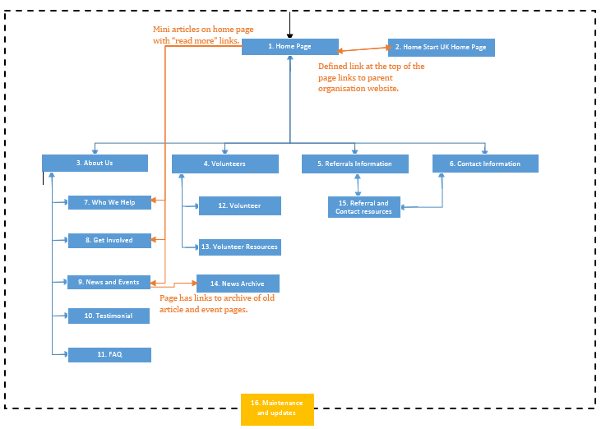

1. Home page

This is the core index page of the site, which users are greeted with first upon accessing the website. Like every page, it will feature the same navigation bar at the top that will link to almost every other web page on the site. At the very top will sit a distinct link to the Home Start UK website, the parent organisation of the South Derbyshire branch. This is to connect the two websites together in case people visiting are curious about the bigger picture. It will contain the basic information that introduces the organisation to all users and is intended to interest them if they are user seeking to get themselves involved with Home Start.

1. Home Start UK home page

As previously stated, this page is connected to the Home Start South Derbyshire website, through a clear link always present on the navigation bar. Whilst not specifically linked both ways, this site contains more information on the organisation such as the global scale of the organisation and its history. This is specifically for use by users such as families, volunteers or funders, as the site will contain relevant information to all of them (E.g. Reports, Interviews, Testimonials).

1. About us

One of the main pages linked to through the navigation bar, which will contain fundamental information that defines what Home Start is and what it does. This is most likely to be used by the common users (Families, Funders, and Volunteers) to look up the basic information about Home Start.

1. Volunteers

A page specifically for use by volunteers, where it outlines the basic information about becoming a volunteer and why alongside their general duties in a summary.

1. Referrals information

Targeted at families, this relates to referrals from existing establishments beforehand to provide any further information they may need relating the two. An example would be info about who specifically refers people and why.

1. Contact information

Contains contact details to get in touch with the organisation through different channels. Would be used by any user seeking to interact further with the organisation, where they would need contact details such as an e-mail address or a telephone number.

1. Who we help

General information section covering in greater details, who falls specifically under the criteria for help from Home Start. This is specifically intended for use by families, to check if they are applicable for help from the organisation.

1. Get involved

Page containing information on the different ways people can get involved with the organisation, mainly for use by funders who will be interested in how they can provide help.

1. News and events

A general page that contains the latest articles and entries for events from Home Start. It can be looked at by any user interested in any new articles containing information relevant to them that they may search for. An example would be a funder searching for financial reports.

1. Testimonial

Small page designed to convince people of the quality of Home Start’s services through stories of previous families involved. Designed mainly to be used by families to convince them to seek help from Home Start, but other users may seek this information too.

1. FAQ

A frequently asked questions section, intended to be accessed by any user to potentially answer any clear questions that they may have about the organisation. Laid out in a simple list, the information to be given to users is presented in a simple, readable way.

1. Volunteer

Expanding upon the section from before, this page contains information and instructions about the procedures of volunteering and existing volunteers. Evidently, this is information intended for potential volunteers of Home Start as it matches their purposes best.

1. Volunteer resources

Linking to the last page, this is a page that provided the downloadable resources for applying to become a volunteer for Home Start. This page will have been linked to the previous page for best efficiency in the application process through a link.

1. News archive

Connected to the news and events feed, this is to act as an archive of older articles that can be searched through by users for varying purposes similar to that of the original feed. They’ll be able to make queries through a search bar that allows articles to be filtered through different criteria.

1. Referral and contact resources

This is a page of information that could be accessed to find necessary resources on getting in touch with Home Start and applying for help. This is mainly for use by Families and Funders here as they would need this most.

1. Maintenance and updates

This maintenance and updates that my client will make on a regular basis. It will mostly be updating the news feed and archive, but the site can also be updated with new files to download and re-written pages.

Benefits of system

The result of implementing this proposed system is that it should be able to improve the financial standing of the organisation in the long term. This is due to the fact that the website for Home Start acts as the primary outlet for promoting it and its purpose to clients and funders. If it were to be improved through an overhauled design that is far superior, it is likely that more potential clients and funders may come forth due to the increased appeal and online exposure, which mainly comes from the system’s link into social media. As a result of this, more money will flow into the business, increasing financial security in the long term.

Client services and relations are also likely to be improved by the new system that I have proposed. With the original system, I identified a fundamental issue with how the content and pages were organised on the website, in which it confused clients at times and turned them away. Taking in what I have previously observed and improving the system, has resulted in the development of a new system concept in which the organisation of content and navigation has been made smoother and simpler. By implementing an improved system, the clients for Home Start will reap the benefits from having a better user experience and as a result, it should improve the trust between Home Start and its clients due to them having an experience without issues.

Time saving is also a benefit that can come from the implementation of my proposed system. Looking at the existing system, its navigation and processing can be considered clunky and confusing in places. Using a new system that will streamline navigation by making it clearer with newer features (Such as navigational sub headers for sections of the website) will improve the overall time efficiency for navigation and obtaining files. Updating and maintaining the system should also be much faster due to the planned back-end interface, usable by me and my client. This will mean the updates to the system should take much less time and be easier.

Impacts of system

An impact of using my proposed solution is that one should see an increase in online exposure for Home Start. This will be due to an increased linkage to existing social media and better appeal to the target audiences of the site with its overhaul. As such, being an improved primary outlet for people to access information on Home Start South Derbyshire should increase the overall exposure and traffic for the website.

Increased income is also to be expected if linked in with the benefit regarding improved financial stability. Although, it must be acknowledged that expenditure will still exist for the website in regards to a host and the domain rights. However, it is best to look at how the increased exposure of the organisation online improving the overall income, if it interests potential funders more and has increased popularity. Building further upon this, it can then be assumed that there would be an increase in clients too if the websites overhaul promotes Home Start better, alongside providing resources easier compared to the old website.

The efficiency for the application process with volunteers should also see a relative improvement, as the existing website has been reported to confuse a number of people accessing the resources, which would slow the procedure down. Thus, improving this part of the website to be clearer should have the impact of making the application process for potential volunteers smoother.

Deliverables

* What I shall deliver as a solution is a new website to act as the main online resource for Home Start SD. What it must deliver at the end is a functional system that:
  + Promotes the organisation to new clients, volunteers and funders.
  + Provide extensive contextual information on the organisation to the target audiences.
  + Provides details and resources for people to apply for jobs within Home Start SD or become involved.
* As a part of the project, I shall also deliver detailed designs that extensively show what I intend to produce for my client, where they cover every part of the website that I shall produce.
* I will also carry out several bouts of testing with the solution to prepare it for implementation. This can be carried out with my client and independently, but in the end I shall report back to them in order to check that my solution is meeting their specifications.
* With the solution, what I shall provide to my client is solely the website and the software interface to edit parts of it. Hardware needed to access and use what I provide, must be provided by Home Start itself. This includes regular computer systems, which I am aware they already possess.
* The host to enable the website to be put online, shall be partially provided by me, in which I shall advise Home Start on which to use. The payments to support its use must be provided by Home Start itself though, as it will become their responsibility to keep their website going.
* Training shall be provided to my client prior to the implementation of my solution, to give her direct instruction as to how it should be used. What I refer to here, is the back-end interface for updating the website. I shall guide her through its typical usage on updating the website and how to carry out updates regularly.
* I shall also provide a guide of sorts, to act as a reference for instruction on the use of updating the website, in case my client forgets something. This user guide will provide basic information and troubleshooting, and will be made to be user friendly and easy to follow.

### 2.3 System Processes

Below is a basic webpage structure for Home Start website, where blue denotes specific webpages and orange indicates direct navigational features.

*Note: The way in which this is organised, divides the structured pages by specifically unique content. For example, pages with simple images and text will be discussed together, and others with entry forms will be too.*

* Navigation bar
  + Each page on the site will contain the navigation bar positioned at the very top. Obviously, there is little to process here other than mouse clicks on particular regions of the bar. These interactions would be processed to produce the output of loading the webpage, corresponding the part of the navbar clicked.
* Page [1]
  + This part of the website is the home page, which will consist of content such as images, links and text. The only input that a user can enter will be mouse clicks, to interact with links on the page, which are connected to articles. The system will then have to process which article connected to a link and output the specific webpage that was connected.
* Pages [3, 4, 5, 6, 7, 11, 12]
  + These pages are variety of pages that serve different purposes, but have a distinct lack of unique content that may be interacted with. These pages are only expected to consist of text, images and other miscellaneous content, but it will not be interactive, thus making these pages have a lack of inputs, processes and outputs (Excluding the navbar).
* Page [8]
  + This page is the “Get Involved” page, which contains information on available positions in which one can associate themselves with Home Start. It can contain interactive content, like links to connected pages and scripts to list the positions in a reel. Either of these things can be interacted with, through a mouse click. Upon doing this, the system will process the interaction in accordance with the content to produce the output of webpages associated with the content (The reel will link to pages detailing job information.
* Page [9]
  + This page is the “News and Events”, which contains the most recent posts made by my client, the intended administrator of the website. Each event will have at least a link representing it and potentially an image. Either of these can accept the input of a mouse click, which the system will process to load up the specific article from the small database of articles. The output will then the loading of the specific article webpage.
* Page [10]
  + Known as the “Testimonials” page, the outdated version of this webpage used simply text to display these, whilst the new page will be revamped to resemble the original layout of the “Who we help” page. It will use scripts, so that clicking on a thumbnail will have the system process what to load. Depending upon which thumbnail was clicked, a different output of a small on-page pop-up will appear, containing a testimonial.
* Page [13]
  + Volunteer resources is a page that will contain download links for documents needed for people to apply for the position as a Home Start volunteer. Ignoring any other content, these links will be the only thing able to accept the input of a mouse click. Upon the event of this occurring, the system will process the request of the specific link and initiate the appropriate download as the output for this page.
* Page [14]
  + The News Archive is a unique section of the website, connected to a separate, small database like the active articles. Here, similar to the other articles, mouse clicks on their links can be processed to load the articles. However, there is also going to be the option to enter alphanumerical data into a text field at the top, to filter articles. When text is entered, the website connected with the database will carry out a look-up to check if the entered text string corresponds with existing articles. The output of this will be the search results of articles, with names similar to text entered in the search bar.
* Page [15]
  + Referrals and contact resources is the final page that may contain any interactive content on the website. Ultimately, this can be seen as virtually the same, as mouse clicks will be accepted as an input that is processed to retrieve contact information or files available for download.
* Maintenance and updates [16]
  + This final part entails the back-end interface that my client will use to update content on the website with. The primary function of this is to allow articles to be created, updated and archived. In regards to this, my client will input alphanumerical information into the system and use mouse interactions to confirm their choice or any revisions. The system would then process whether or not the article was new or existing, creating a new article or altering one accordingly. If an article is new, the system will check what the most outdated one is and then archive it and update the listings to include the newest one. Ultimately, the output here, is an update to the article listings on the news page and an update to the archive.

### 2.4 User Skills

|  |  |  |  |  |
| --- | --- | --- | --- | --- |
| **User Category** | **Skill Level** | **Use of System** | **Design Considerations and Features** | **Training Requirements** |
| Client | * Considered to have the bare minimum skills for computer use within a business. * Supported by how she handles the production of documentation sends most emails and manages the social media for the organisation. | * My client is expected to typically use my developed system for the purpose of updating it for the audiences. * Whilst she may access the website at some point, her main use of the system will be the back-end interface to update documents and articles on the website. | * House style and layout of interface to make it as user friendly as possible for my client. * Tooltips as a feature of the interface to provide small tips on what to do, such as when they fill in certain fields. * The labelling of fields and navigation must be considered, so my client clearly enters information and can find parts of the system with ease. * Error messages should also be included in the system to notify my client over any erroneous operation. | * Before the system can be fully implemented my client will need to be shown how to use the back-end interface of the site. * The training should run her through how to access the system and what parts of the website it links to and what it affects. * Next, she will be trained in using the interface to update the website until she gets used to the idea of updating it. |
| Volunteers | * Can be from a varied age range, estimated 20 years+. * As such, it would be best to assume that some volunteers for Home Start may possess little skills with digital technology. * Although in order to access the website in the first place, they must have at least a most basic concept of technology. | * Users of my system in this group are expected to use the system to access information and documentation about volunteering for Home Start South Derbyshire. * Looking at information will typically entail basic research into the organisation’s purpose and what they do. * The documentation they would need to access would primarily include application forms. | * As with most, the layout and navigation (Through the navbar) of the website is an important consideration. Volunteers will want to access information and files, so being able to find it in clear, logical locations is best. * The house theme should also be adapted so that the colours and fonts look professional and appealing to volunteers. | * Across the website for all users, the only training that can be provided is clear navigation that makes it easy to use the website or a help section to help navigation. * The help section can be included as a part of the navigation bar to help users figure out where to find what they need. |
| Funders | * Skill level assumed to be bare minimum; however a funder is potentially more likely to have experience with technology if they find organisations to fund online. | * With what they do, a funder would use the system to research Home Start; what it does, who they have helped and how they do it. * The information and layout that they look at will provide their first impressions on the organisation. * May be inclined to view articles that may be either active or archived for further information. | * As they will be looking to see what the organisation does, a good first impression upon potential funders is important. The house theme of the site should be made so that it looks clean and professional. * Navigation and layout should be done in a way to keep the site in a neat structure, with information easy to locate. * For finding articles in the archive system linked with the website, a suitable form would be needed so that making a query to find something specific is easy and simple. Tooltips or labels can be used to make understanding the interface easier and quicker. | * Should be the same uniform training as volunteers. |
| Families | * The skill level of families (namely, the parents) must be assumed as them having little experience with technology other than accessing the web. * As Home Start targets newer families though, it is most likely that the ages of these users will be between 18 and 30. Thus, they are more likely to possess skills with digital technology. | * Families are the clients for Home Start South Derbyshire and will be expected to access and use the system with purposes similar to other audience groups. * What is expected, is that they would use it to gather information on what Home Start does and what it can do for them. Then they would use it to find contact details, to get in touch if they were so inclined. * They may look at the articles available on the website, if they are interested in finding further information. This can result in them going through the archive too. | * As the goal of Home Start South Derbyshire is to provide help for new families struggling from various factors, including disabilities and mental health issues, accessibility features like a high visibility mode should be included. * The website navigation and layout will need to be kept as simple as possible, so there is little confusion at navigating the site. * The house style should also be done to be appealing to people. * A suitable form layout must be used for entering a query into the system for finding specific articles in the archive. It must be simple to comprehend and could provide basic instruction, perhaps in the form of tooltips. | * Should be the same uniform training as volunteers. |

### 2.5 Evaluation Criteria

**Qualitative Criteria**

|  |  |  |  |  |  |  |
| --- | --- | --- | --- | --- | --- | --- |
| **No.** | **Criteria** | **User Req.** | **Criteria Met?** | | | **How it Checks Against User Requirements** |
| 1 | Has the location of the downloadable files from the previous website been improved, so that it is much easier for users to find them? | **4** | **Yes** | **No** | **Part.** | Used to see if the system has been structurally overhauled, so accessing stored files is easier. |
| 2 | Is the system presented in a new layout that looks professional and is much more user friendly? | **5** | **Yes** | **No** | **Part.** | Checks that the website meets the requirement of having a more user friendly layout, that isn’t confusing. |
| 3 | Is locating information on the website easier than it was with the previous website? | **5/6** | **Yes** | **No** | **Part.** | Checks to see if the new website has a layout that makes the overall process of finding different pieces of information about Home Start easier. |
| 4 | Has the navigation on the site been overhauled appropriately, so users can find pages easily? | **6** | **Yes** | **No** | **Part.** | Ensures that the changes to the navigation has made accessing web pages easier. |
| 5 | Can the login system for the back-end of the site check if logins are acceptable and can it use this to lock people out? | **7/**  **10** | **Yes** | **No** | **Part.** | Makes sure that the login system is capable of using validation and verification to make sure logins are valid and also uses this to keep unauthorised users out. |
| 6 | Does the back-end interface allow for the editing of suitable content on the website, a feature not available to the previous website? | **11** | **Yes** | **No** | **Part.** | Used to see if the back-end interface is able to fulfil my client’s specification of being able to edit certain parts of the website’s visual content. |
| 7 | Is there helpful features such as tooltips included with the back-end interface that build upon other training? | **12** | **Yes** | **No** | **Part.** | Checks that appropriate measures are in place to provide some extra help to users after the system has be implemented. |
| 8 | Is the overall system kept more secure than the previous, through better hosts, security and passwords? | **10** | **Yes** | **No** | **Part.** | Ensures that the entire solution has been secured properly, with necessary security features. |

**Quantitative Criteria**

|  |  |  |  |  |  |  |
| --- | --- | --- | --- | --- | --- | --- |
| **No.** | **Criteria** | **User Req.** | **Criteria Met?** | | | **How it Checks Against User Requirements** |
| 9 | Is the system able to accept click-based inputs? | **1** | **Yes** | **No** | **Part.** | Checks whether or not the system is able to accept the correct inputs from click-based interactions |
| 10 | Is the search bar able to accept character inputs? | **1** | **Yes** | **No** | **Part.** | Checks whether not the system can accept suitable character input in the fixed field. |
| 11 | Can the system respond correctly to corresponding mouse clicks? | **3** | **Yes** | **No** | **Part.** | Makes sure that the website correctly processes and outputs what corresponds to mouse interactions on interactive content. |
| 12 | Do queries produce correct results? | **3** | **Yes** | **No** | **Part.** | Ensures that the search bar queries correctly verify information in the database to produce the correct output. |
| 13 | Is the back-end of the website protected with a secure password? | **10** | **Yes** | **No** | **Part.** | Checks that the website login is suitably protected with a password for users, to keep unauthorised people out. |
| 14 | Does the system meet the minimum hardware requirements specified? | **8** | **Yes** | **No** | **Part.** | Checks that my system is capable of being run effectively on the specified minimum hardware. |
| 15 | Can the system run on the existing hardware at Home Start? | **8** | **Yes** | **No** | **Part.** | Done to make sure that the website solution’s interface can be run on the existing computer systems at Home Start, as they may not align with the minimum requirements. |
| 16 | Is the system fully compatible with the software requirements? | **9** | **Yes** | **No** | **Part.** | Checks that my website is fully compatible with all specified software. |
| 17 | Does the back-end interface function properly? | **11** | **Yes** | **No** | **Part.** | Ensures that the back-end interface is able to start and connect with the website. |
| 18 | Does the back-end interface feature an interface that is as simple to use as the website? | **11** | **Yes** | **No** | **Part.** | Checks that the interface is suitable and simple, so it is easier for client use. |
| 19 | Can the back-end interface edit suitable content on pages, including articles, as well as archive old content? | **11** | **Yes** | **No** | **Part.** | Makes sure that the interface meets its specified purposes, being able to complete all of them. |
| 20 | Is the overall system designed so that as little training as possible is needed to use it? | **12** | **Yes** | **No** | **Part.** | Checks that the system has been made so that it can be as simple to understand as possible, to make users capable of using it with as little aid as possible |
| 21 | Is a backup copy of the system and all of its files kept in place and updating at least once a week? | **10/**  **11** | **Yes** | **No** | **Part.** | Ensures that there are appropriate measures in place to keep backups of the website and its files to make sure they are not lost in the event of a disaster. |

**End of Section 2 sign off:**



# SECTION 3 - Designs

### 3.1 Solution Designs

***Introduction to solution***

The final solution that intend to produce in this project will be a new website for Home Start South Derbyshire. I was originally tasked to produce this solution by my client Tracey Harris, in which I would replace and overhaul their existing web-based outlet, which is used to promote Home Start online and provide accessible resources. The chosen solution will improve upon the flaws of design and navigation that ails their existing website through a new, cleaner interface and improved file access. This will entail the implementation of a new layout and house theme, with the navigational links improved, so that finding information and files is far easier. An integrated interface will also be featured, which will enable even my client to make changes to content, whenever she deems it acceptable.

https://github-atom-io-herokuapp-com.global.ssl.fastly.net/assets/logo-4e073dbd4c0ce67ece1b30a6b31253b9.png The specific software that I intend to use to produce this website is Atom and Concrete 5, which I will use together to produce my full solution. Atom, is the text editor and main development environment that I will be using for this project. I chose this over other development software, as I evaluated that it has the most functionality and will prove to be most useful. The software itself is open-source and has a large supportive community to help users of the software. It is bundled with features such as project management, auto-completion of code, multiple editing windows, etc. Overall, I have found that this software meets my needs the most and will allow for the most efficient writing of code.

The other software that I shall be using is Concrete 5, a content management system that I will be using in order to create the back-end interface for the website. I will use Concrete 5 to provide dynamic content management on the webpages in my final solution. What this is intended to is to allow even my client to edit, remove and add custom content to the website whenever she sees fit. I chose this as the most suitable package to use in this project as it is free, easy to use and has a lot of variable extensions and community support. Evaluating these factors with other possible software, I ultimately decided that this would prove to be most beneficial.

When considering how I should carry this out however, I first reasoned with different ideas on how to, but finally settled upon producing a website solution for the organisation. The considerations I made involved the coverage of potential alternate solutions and software that I could use for development of my final solution. The reasoning I used to make this decision is explained below.

***Alternative Solutions***

Producing a website for a solution was the very first option considered by me, as it is most applicable to the given user requirements, being flexible enough to completely meet assigned tasks. This would easily allow for a bespoke solution that can act as a primary online outlet for the organisation, with easily accessible files for users and a unique interface for my user to make changes when she sees fit. Whilst the work involved in the setup, production and training for a solution would be tremendous, I will stand by the level this solution fits with the user requirements and how my client Tracey specified in our first meeting as her most desired solution; An online website that has accessible files and can be updated by her, to save hassle.

Social media was one of the first possible methods of creating a solution for my client. I am aware that they already manage and use two different social media outlets with the services Facebook and Twitter. My client Tracey discussed this with me in our initial briefing, in which Home Start South Derbyshire uses Facebook as a private discussion group between volunteers and Twitter is used as a news outlet. Whilst I had considered the possibility of switching everything to social media, it would be rather limited in resource availability and would be quite awkward for many users. Whilst it would reduce costs and the size of the solution, Tracey explicitly stated to me that she would like to have a solution linked to social media, as such choosing a 100% social media solution was no longer an option.

Another possible solution to consider was to use digital services that enable websites to be produced from pre-existing templates. These services are often online, usually providing both free and “premium” templates if not charging a fee for usage. Utilising these services could prove useful as the process of producing and editing the website would have been simplified. The interfaces and layouts will have also been previously thought out, so they are most suitable for web design, aligning well with the design requirements for my users. What this service lacks however is a bespoke nature, which does not align very well with the user requirements. This is because, there is a fair bit of custom content (such as the back-end interface) which these services cannot offer without additional aid, like plugins (Which can often cost extra money). Considering the possibilities of limited use and extra costs, I decided this approach would not be best for producing a solution.

Email listings is another potential approach that could be considered as a solution to use, in which people can sign up to an email list that is used to send promotional material, resources and other content en mass to clients of the business. Whilst this solution can be used to reach a large number of people through an often used service, it would be best as a subsidiary solution that supplements a larger solution. This would particularly be needed in order to initially acquire emails from clients. The system would be quite simple though, allowing specific media to be directly sent to different groups of signed up clients. However, as just emails it could still be considered spam to people and may be trashed immediately. Having evaluated these factors, I would say that using solely emails is most unsuitable, not aligning with my user requirements well due to a lack of extended functionality and independence. This solution also makes the management of sending documents to users such as volunteers difficult alongside getting in touch in the first place.

Traditional advertising is the final approach considered as a solution in this project. What this could entail is any form of promotional material used to communicate with the audience of Home Start, including posters, leaflets, web-adverts, etc. This does at least align with the core user requirements of communicating information with clients, however it could be hampered by the fact that this would be a medium for basic advertisement and nothing else. To go further, would involve things such as promotional videos, which would cost a lot of money. This also ignores a key requirement of providing an accessible resource of documents for users such as volunteers, as there would be no set location in which to access them. It must also be mentioned that a solution of this nature would be near impossible on its own, as it would best would as a supplement to a larger solution such as a website or social media. As such, I decided easily that this solution was not suitable and chose to continue with developing a website solution.

As I stated in my introduction, I ultimately chose out of all solutions to produce a website, best exemplified by the same reasons I considered it a solution option from the start. However, from having looked at these alternate options, it has come to light that other solutions could be used side by side with it to supplement the final website solution. For example, my client already uses social media and has suggested linking the two, so a synergy of the two could expand the range of possibilities for the solution. Other alternatives could be used alongside a website, but I have concluded that it is more than sufficient for meeting my user requirements.

***Alternative Software***

Notepad is a basic text editor and the very first alternative software considered for developing my chosen solution of a website. This would have been used for manually writing the code for the website solution and changing it into the appropriate file format. Looking at what I need in this project, which is software that will help me efficiently program the solution, Notepad satisfies this basic need to some extent as I can at least write code and save it into the appropriate file format. However when compared to Atom, my chosen software it lacks functionality in utility to aid in an effective development. Whilst specifics involving the programming of the solution were not detailed entirely in my user requirements, a software that would potentially impede production should be ruled out, as I have done.

Notepad++ is a software more focused towards programming as a text editor, having features such as colour coding for programming languages and predictive text to make coding more efficient. When evaluating what would be needed as a software to program, this surpassed Notepad easily, but came close with Atom. Both provide similar features to aid in programming specifically, but Atom does possess more advanced features and is backed up by a helpful community with accessible resources. Thus, I chose quite simply not to use Notepad++ for coding.

Adobe Dreamweaver is an integrated software environment tailored for web-development that was considered as a potential software to develop the website solution. What sets this aside from previous software is that it is not simply a text editor, but an environment that allows websites to be developed graphically as well. This can be very beneficial to production as it makes development easier due to being able to directly edit a website graphically and saves time and effort at checking changes made. However, what I intend to program for my website is better carried out by a full text editor like Atom, as it is tailored to focus on programming with simply code, which allows me to produce a bespoke solution. Overall, I evaluated that Atom will be the better choice in advance, as it will allow my solution to be more advanced and efficient.

Edhita is the final software that was considered as an alternative, which is an integrated environment like Adobe Dreamweaver. What sets this apart however, is that it is compact and it operates on mobile devices. This would allow for web development to be done on the go, but it was quickly ruled out as the software lacks features that the others have such as highlighted code and writing code on a mobile device is exceedingly tricky. As such, I quickly decided that it was not suitable software to use, as I would not be able to meet my user requirements effectively.

Atom was the last of the editing software that I looked at for developing my chosen solution, which possesses more useful feature than each of the previous programs, excluding display windows featured by Dreamweaver and Edhita. These features include seamless multi-https://github-atom-io-herokuapp-com.global.ssl.fastly.net/assets/logo-4e073dbd4c0ce67ece1b30a6b31253b9.pngwindow working, project management and most importantly, a large community to support coding work and the use of the software. Using such a feature would enable one to get the hang of using new programming languages and the program itself much easier and would provide great support. Whilst checking and testing code for web-development through Atom still requires the use of checking through a separate browser window, I still conclude that the features of Atom exceed the other software discussed above.

SQL Tables was an alternative solution considered for the back-end interface system, in which the content of the page would be linked to files written in SQL. If this was in place, the website would simply have to read the contents of the files to determine what to display. This does however; present the possibility of only limited content being displayable and a potential difficulty with my client accessing and using it to update the website. Whilst this option may somewhat satisfy user requirements, the last two points violate the requirements of having a back-end to the site that allows for a variety of dynamic site updates at the discretion of my client. Considering this and comparing with other alternatives, I decided that this option would not be beneficial if implemented. XML Files were also considered for this, but are practically the same as using SQL Tables. The main difference here would be that they are likely to be less compatible and even more basic in available functionality if implemented in the solution.

Concrete5 is the final piece of software that I looked at, in which it is a content management system that can be used for websites to create updateable content. This features a much simpler method of linking content on a website, whilst making it easier to edit it when desired. This also features the option for add-ons that can be free or cost money and it is backed up by a community with support to offer. Whilst learning how to use it and set it up may be a hassle, I’ve decided that it is more practical than previous options for supplementing the website with a means to edit and update it.

As such, moving on to why I chose to use Concret5 and Atom as my pieces of software of choice; I compared their features to everything else and concluded that they would bring me closest to meeting my user requirements. Concrete5 fulfils the requirement of producing an editing interface, whilst Atom will allow me to most effectively produce a solution that meets every other requirement. Whilst it is simple, the features presented by this software outweighs the others in effectiveness and usefulness and that is why I chose them.

### 3.2 Test Strategy

The website solution that I am to produce for my client Tracey Harris of Home Start South Derbyshire will require rigorous testing before it can be finished and implemented permanently. Across the production, I will need to carry out three stages of testing: Functional Testing, Environmental Testing and End-User Testing. These three parts of testing will be carried out at separate times to ensure a smooth as possible system implementation and to ensure that it meets my user requirements. The three sections of testing are as follows:

**Functional Testing**

This testing will take place directly after I have produced my first official version of the solution. It will be done to test all possible technical aspects that the system is comprised of. As such, it will be carried out in a linear series that orders each part of the system to be tested numerically. Each part of the system to test will also be cross-referenced with my user requirements to ensure that these tests prove relevant to this project. With each test I will outline specific data I will use to test alongside the method of carrying out the test and why. I shall then proceed to observe the outcomes of each individual test and compare this to a predetermined ideal outcome. If these do not match precisely, then corrective action may be taken to fix any issues that have arisen. The corrective action will include a targeted focus upon the error located in the solution that I will work at until it is resolved, otherwise the solution will not function correctly.

This initial stage of testing is essential, so that I can ensure that the system will function correctly by my standards prior to its introduction to my client. This testing will be carried out by myself over several hours to make sure that user requirements are properly met. It will be done within the development environment that I have chosen, so that is most efficient and because my client does not need to be involved in feedback at this stage.

**Environment Testing**

This stage of testing will be carried out shortly after the corrected system has been produced by me and deemed suitable for implementation. This premediated testing is a check to ensure that my system can be implemented with the hardware that will be used to operate and manage it. It will also be needed to make sure that it will fit in correctly with the office for Home Start South Derbyshire and not create any interference. As the system will be run off a separate server, these issues would most likely be localised to the host. In this case, I will need to research and test running my solution on the server in advance, so that it will work without issues when it is fully implemented. If the host is deemed unsuitable or incompatible, then I will take action to locate a more suitable host that will enable me to host the solution. In the Home Start office systems, the website will have a back-end access that will be run through some form of editor. There is the potential of compatibility issues or basic functionality issues, thus I will have environment testing done first to eliminate this risk. All of this testing will typically be carried out through a checklist/table that will outline focused criteria to test in the environment, what is expected to happen, what happened and action taken to correct it.

**End-User Testing**

This is the final step of testing that I will take is testing that involves my client in the environment of the Home Start office. At this stage, the system will have been implemented and will be operational. The main focus of this testing is to ensure that the system can be used by my client and that it meets their standards. As such, this will involve a feedback driven questionnaire that targets the outlined user requirements and fundamental features of the website system, so my client can identify areas that they are not satisfied with. Features such as layout, style and even page design and content will be included as the testing must be thorough, so that the final solution can be produced. When my client will identify issues in the questionnaire, I will then go and make amendments in that area based on the feedback and present the system again. If this still has issues, then I will go and amend issues as many times as it is needed. The user guides and instructions provided will also be tested for any issues or weak areas to be improved. Similar to the system, sampled feedback will be collected for the use of updating and correcting the guides, so that they are most suitable for my client.

# SECTION 4 – Testing

### 4.1 Functional Test Plan (Next Page)

| **Test No.** | **Test** | **Test Data** | **Expected Outcome** | **Actual Outcome** | **Corrective Action** | **User Requirements** | **Evaluation Criteria** |
| --- | --- | --- | --- | --- | --- | --- | --- |
| 1 | Test that each link on the navbar goes to the correct webpage. | Click | When each link included along the navbar is clicked, the corresponding webpage will be loaded up |  |  | 1,2,3,5 | 2,3,4,9,11 |
| 2 | Test home page links | Click | Any links on the home page will direct a user to the correct content they specify |  |  | 1,2,3 | 2,3,4,9,11 |
| 3 | Test about page links | Click | Any links on the about pages will direct a user to the correct content they specify |  |  | 1,2,3 | 2,3,4,9,11 |
| 4 | Test contact page links | Click | Any links on the contact page will direct a user to the correct content they specify |  |  | 1,2,3 | 2,3,4,9,11 |
| 5 | Test news article links | Click | Any links that lead to news articles will take a user to the corresponding article shown |  |  | 1,2,3 | 2,3,4,9,11 |
| 6 | Test news archive links | Click | Any links to archived articles will take a user to the correct articles |  |  | 1,2,3 | 2,3,4,9,11 |
| 7 | Check that the house style and theme meet specifications | NA | On all pages of the website, the predetermined house style will be consistently displayed, including fonts and colours |  |  | 3,6 | 2,3,4,9,11 |
| 8 | Check that each page had been laid out according to the predetermined general structure with bootstrap | NA | According to the grid-style layout used, the page should be divided up into separate rows and columns |  |  | 3,6 | 2,3,4,9,11 |
| 9 | Test bootstrap by placing sample content into the predefined sections on Home page | Text: “Lorem Ipsum…” | All text on the home page should display correctly with correct wrapping and formatting |  |  | 3,4 | 2,3,4,9,11 |
| 10 | Test bootstrap by placing sample content into the predefined sections on About pages | Text: “Lorem Ipsum…” | All text on the about pages should display correctly with correct wrapping and formatting |  |  | 3,4 | 2,3,4,9,11 |
| 11 | Test bootstrap by placing sample content into the predefined sections on Volunteer pages | Text: “Lorem Ipsum…” | All text on the volunteer pages should display correctly with correct wrapping and formatting |  |  | 3,4 | 2,3,4,9,11 |
| 12 | Test bootstrap by placing sample content into the predefined sections on Contact page | Text: “Lorem Ipsum…” | All text on the contact page should display correctly with correct wrapping and formatting |  |  | 3,4 | 2,3,4,9,11 |
| 13 | Test bootstrap by placing sample content into the predefined sections on News pages | Text: “Lorem Ipsum…” | All text on the news pages should display correctly with correct wrapping and formatting |  |  | 3,4 | 2,3,4,9,11 |
| 14 | Test functionality of image gallery on home page | Images, Click | All images should be displayed in the gallery and it must cycle between them correctly |  |  | 1,2,3,4,5 | 2,3,4,9,11 |
| 15 | Test functionality of the image gallery on the About pages | Images, Click | All images should be displayed in the gallery and it must cycle between them correctly |  |  | 1,2,3,4,5 | 2,3,4,9,11 |
| 16 | Test that download links can be accessed and initiated successfully | Click | When the download links are clicked, they should initiate without issue |  |  | 1,2,3,4,5 | 1,2,3,4,9,11 |
| 17 | Test that active news pages can be created | Click | When coded in, news articles can be added and displayed correctly on the website |  |  | 1,2,3,4,11 | 6,7,17,19 |
| 18 | Test of moving outdated articles to archive section | Click | Articles that are designated as outdated can be put into the archive, where they will still be locatable |  |  | 1,2,3,4,11 | 6,7,17,19 |
| 19 | Check that news articles can be viewed correctly and that the formatting is consistent | Click | All news articles should use the same consistent formatting across them |  |  | 3,4,5,11 | 6,7,17,19 |
| 20 | Check that Concrete5 and other plugins have been correctly installed by testing functionality | Images, Text: “Lorem Ipsum…” | Concrete5 will function correctly with the sampled linked data functioning properly |  |  | 1,2,3,4,11 | 5,6,7,8,13,17 |
| 21 | Test that Home page content of images and other text is applicably linked through Concrete5 | Images, Text: “Lorem Ipsum…” | All images and text linked through Concrete5 will be displayed in their correct locations |  |  | 1,2,3,11 | 6,7,17,19 |
| 22 | Test that About pages content of images and other text is applicably linked through Concrete5 | Images, Text: “Lorem Ipsum…” | All images and text linked through Concrete5 will be displayed in their correct locations |  |  | 1,2,3,11 | 6,7,17,19 |
| 23 | Test that Volunteers page content of images and other text is applicably linked through Concrete5 | Images, Text: “Lorem Ipsum…” | All images and text linked through Concrete5 will be displayed in their correct locations |  |  | 1,2,3,11 | 6,7,17,19 |
| 24 | Test that Contact page content of images and other text is applicably linked through Concrete5 | Images, Text: “Lorem Ipsum…” | All images and text linked through Concrete5 will be displayed in their correct locations |  |  | 1,2,3,11 | 6,7,17,19 |
| 25 | Check that news can be edited and created through the back-end | Click, Text: “Lorem Ipsum…” | When carried out, a new article can be written and then directly posted into the active news feed |  |  | 1,2,3,4,11 | 6,7,17,19 |
| 26 | Test changing the status of news through the back-end to make news in/active. | Click | When flagged like so with Concrete5, articles can be moved from the active feed to the archive of news articles |  |  | 1,2,3,4,11 | 6,7,17,19 |
| 27 | Test that news articles are properly stored within the archive | NA | All articles moved into the archive should all be stored without any issue or alterations to them |  |  | 1,2,3,4,11 | 6,7,17,19 |
| 28 | Test that the search function works properly and can sort and locate articles by date | Text, Click | All articles should be loaded and sorted in date posted order (Which can be oldest to newest or the other way round) |  |  | 1,2,3,4,5,11 | 2,3,4,6,10,12 |
| 29 | Test that the search function work properly and can sort and locate articles by name | Text, Click | All articles should be loaded and sorted in alphabetical order (Which can be A-Z or the other way round) |  |  | 1,2,3,4,5,11 | 2,3,4,6,10,12 |
| 30 | Test presence check validation on the search bar | Text | The search bar should bring up an error when no applicable values have been entered for a query. |  |  | 7 | 3,12 |

| **Test No.** | **Test** | **Test Data** | **Expected Outcome** | **Actual Outcome** | **Corrective Action** | **User Requirements** | **Evaluation Criteria** |
| --- | --- | --- | --- | --- | --- | --- | --- |
| 1 | Test that each link on the navbar goes to the correct webpage. | Click | When each link included along the navbar is clicked, the corresponding webpage will be loaded up | Each link went to the correct page indicated. | N/A | 1,2,3,5 | 2,3,4,9,11 |
| 2 | Test home page links | Click | Any links on the home page will direct a user to the correct content they specify | Each link went to the correct page indicated. | N/A | 1,2,3 | 2,3,4,9,11 |
| 3 | Test about page links | Click | Any links on the about pages will direct a user to the correct content they specify | Each link went to the correct page indicated. | N/A | 1,2,3 | 2,3,4,9,11 |
| 4 | Test contact page links | Click | Any links on the contact page will direct a user to the correct content they specify | Each link went to the correct page indicated. | N/A | 1,2,3 | 2,3,4,9,11 |
| 5 | Test news article links | Click | Any links that lead to news articles will take a user to the corresponding article shown | Some links did not correctly update with the system and failed. | Made sure that the backend updates were correct and updated by re-linking them. | 1,2,3 | 2,3,4,9,11 |
| 6 | Test news archive links | Click | Any links to archived articles will take a user to the correct articles | Some links did not correctly update with the system and failed. | Made sure that the backend updates were correct and updated by re-linking them. | 1,2,3 | 2,3,4,9,11 |
| 7 | Check that the house style and theme meet specifications | NA | On all pages of the website, the predetermined house style will be consistently displayed, including fonts and colours | I found no problem with the house style and theme I laid out in the design process. | N/A | 3,6 | 2,3,4,9,11 |
| 8 | Check that each page had been laid out according to the predetermined general structure with bootstrap | NA | According to the grid-style layout used, the page should be divided up into separate rows and columns | No issues found with bootstrap layout. | N/A | 3,6 | 2,3,4,9,11 |
| 9 | Test bootstrap by placing sample content into the predefined sections on Home page | Text: “Lorem Ipsum…” | All text on the home page should display correctly with correct wrapping and formatting | Issues only encountered, if the CSS properties were not linked. | Altered CSS and HTML files to apply fixes to the content. | 3,4 | 2,3,4,9,11 |
| 10 | Test bootstrap by placing sample content into the predefined sections on About pages | Text: “Lorem Ipsum…” | All text on the about pages should display correctly with correct wrapping and formatting | Issues only encountered, if the CSS properties were not linked. | Altered CSS and HTML files to apply fixes to the content. | 3,4 | 2,3,4,9,11 |
| 11 | Test bootstrap by placing sample content into the predefined sections on Volunteer pages | Text: “Lorem Ipsum…” | All text on the volunteer pages should display correctly with correct wrapping and formatting | Issues only encountered, if the CSS properties were not linked. | Altered CSS and HTML files to apply fixes to the content. | 3,4 | 2,3,4,9,11 |
| 12 | Test bootstrap by placing sample content into the predefined sections on Contact page | Text: “Lorem Ipsum…” | All text on the contact page should display correctly with correct wrapping and formatting | Issues only encountered, if the CSS properties were not linked. | Altered CSS and HTML files to apply fixes to the content. | 3,4 | 2,3,4,9,11 |
| 13 | Test bootstrap by placing sample content into the predefined sections on News pages | Text: “Lorem Ipsum…” | All text on the news pages should display correctly with correct wrapping and formatting | Issues only encountered, if the CSS properties were not linked. | Altered CSS and HTML files to apply fixes to the content. | 3,4 | 2,3,4,9,11 |
| 14 | Test functionality of image gallery on home page | Images, Click | All images should be displayed in the gallery and it must cycle between them correctly | No issues with image reel script. | N/A | 1,2,3,4,5 | 2,3,4,9,11 |
| 15 | Test functionality of the image gallery on the About pages | Images, Click | All images should be displayed in the gallery and it must cycle between them correctly | Some content scaling and placement issues were found. | Fixed by altering CSS properties of the content and altering its overall scale. | 1,2,3,4,5 | 2,3,4,9,11 |
| 16 | Test that download links can be accessed and initiated successfully | Click | When the download links are clicked, they should initiate without issue | Function, but require and available file server. | N/A | 1,2,3,4,5 | 1,2,3,4,9,11 |
| 17 | Test that active news pages can be created | Click | When coded in, news articles can be added and displayed correctly on the website | Using the back-end, new pages can be created under the “active news” flag. | N/A | 1,2,3,4,11 | 6,7,17,19 |
| 18 | Test of moving outdated articles to archive section | Click | Articles that are designated as outdated can be put into the archive, where they will still be locatable | Some test articles did not retain formatting properties during transfer. | Fixed by making the moving procedure semi-manual, in which articles are copied into new ones flagged as “archived” and go into the archive. | 1,2,3,4,11 | 6,7,17,19 |
| 19 | Check that news articles can be viewed correctly and that the formatting is consistent | Click | All news articles should use the same consistent formatting across them | No issues were found regarding the formatting on articles. | N/A | 3,4,5,11 | 6,7,17,19 |
| 20 | Check that Concrete5 and other plugins have been correctly installed by testing functionality | Images, Text: “Lorem Ipsum…” | Concrete5 will function correctly with the sampled linked data functioning properly | Concrete5 did work out as intended and it was concluded to be too complex for use by my client. | Due to this complication from the start, Concrete5 was dropped in favour of a WordPress interface, which proved successful. | 1,2,3,4,11 | 5,6,7,8,13,17 |
| 21 | Test that Home page content of images and other text is applicably linked through Concrete5 | Images, Text: “Lorem Ipsum…” | All images and text linked through Concrete5 will be displayed in their correct locations | Concrete5 did work out as intended and it was concluded to be too complex for use by my client. | Due to this complication from the start, Concrete5 was dropped in favour of a WordPress interface, which proved successful. | 1,2,3,11 | 6,7,17,19 |
| 22 | Test that About pages content of images and other text is applicably linked through Concrete5 | Images, Text: “Lorem Ipsum…” | All images and text linked through Concrete5 will be displayed in their correct locations | Concrete5 did work out as intended and it was concluded to be too complex for use by my client. | Due to this complication from the start, Concrete5 was dropped in favour of a WordPress interface, which proved successful. | 1,2,3,11 | 6,7,17,19 |
| 23 | Test that Volunteers page content of images and other text is applicably linked through Concrete5 | Images, Text: “Lorem Ipsum…” | All images and text linked through Concrete5 will be displayed in their correct locations | Concrete5 did work out as intended and it was concluded to be too complex for use by my client. | Due to this complication from the start, Concrete5 was dropped in favour of a WordPress interface, which proved successful. | 1,2,3,11 | 6,7,17,19 |
| 24 | Test that Contact page content of images and other text is applicably linked through Concrete5 | Images, Text: “Lorem Ipsum…” | All images and text linked through Concrete5 will be displayed in their correct locations | Concrete5 did work out as intended and it was concluded to be too complex for use by my client. | Due to this complication from the start, Concrete5 was dropped in favour of a WordPress interface, which proved successful. | 1,2,3,11 | 6,7,17,19 |
| 25 | Check that news can be edited and created through the back-end | Click, Text: “Lorem Ipsum…” | When carried out, a new article can be written and then directly posted into the active news feed | With the WordPress interface, news content could be created, edited and removed at will with ease. | N/A | 1,2,3,4,11 | 6,7,17,19 |
| 26 | Test changing the status of news through the back-end to make news in/active. | Click | When flagged like so with Concrete5, articles can be moved from the active feed to the archive of news articles | Using WordPress, articles could be moved to and from the archive through copy and paste functionality. | N/A | 1,2,3,4,11 | 6,7,17,19 |
| 27 | Test that news articles are properly stored within the archive | NA | All articles moved into the archive should all be stored without any issue or alterations to them | Articles created appeared to present no further issues at this point when stored in the archive section. | N/A | 1,2,3,4,11 | 6,7,17,19 |
| 28 | Test that the search function works properly and can sort and locate articles by date | Text, Click | All articles should be loaded and sorted in date posted order (Which can be oldest to newest or the other way round) | Typing in the search bar loads up relevant information by text only. | Using WordPress, they could be organised by date much easier and as such, made the search function work. | 1,2,3,4,5,11 | 2,3,4,6,10,12 |
| 29 | Test that the search function work properly and can sort and locate articles by name | Text, Click | All articles should be loaded and sorted in alphabetical order (Which can be A-Z or the other way round) | By default, the search could handle searching articles by name with a text query. | N/A | 1,2,3,4,5,11 | 2,3,4,6,10,12 |
| 30 | Test presence check validation on the search bar | Text | The search bar should bring up an error when no applicable values have been entered for a query. | If nothing is entered then the system will simply output “No results found” | N/A | 7 | 3,12 |

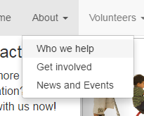

Relevant Test: 1&7

Relevant Test: 2-15

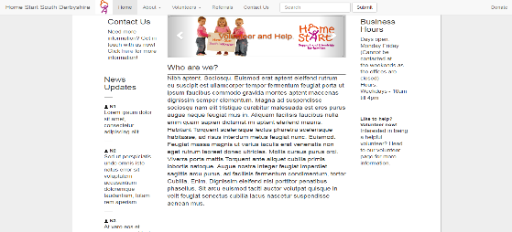

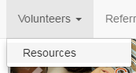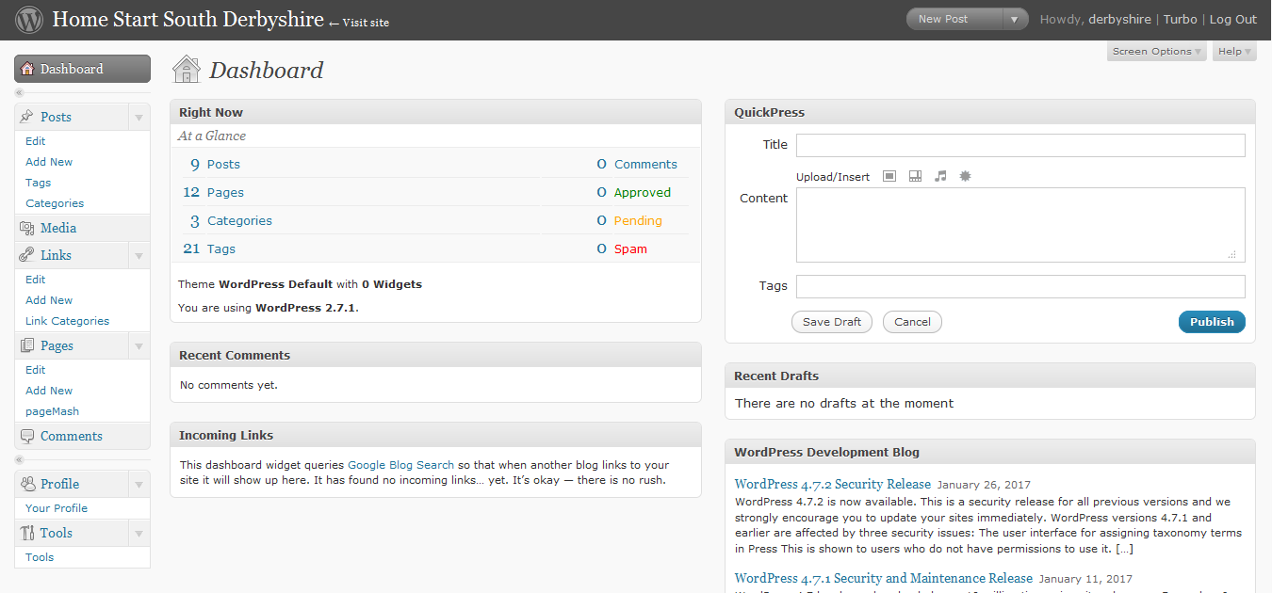

Relevant Test: 15

Relevant Test: 15

Relevant Test: 1&7

Relevant Test: 28, 29 & 30

Figure 7

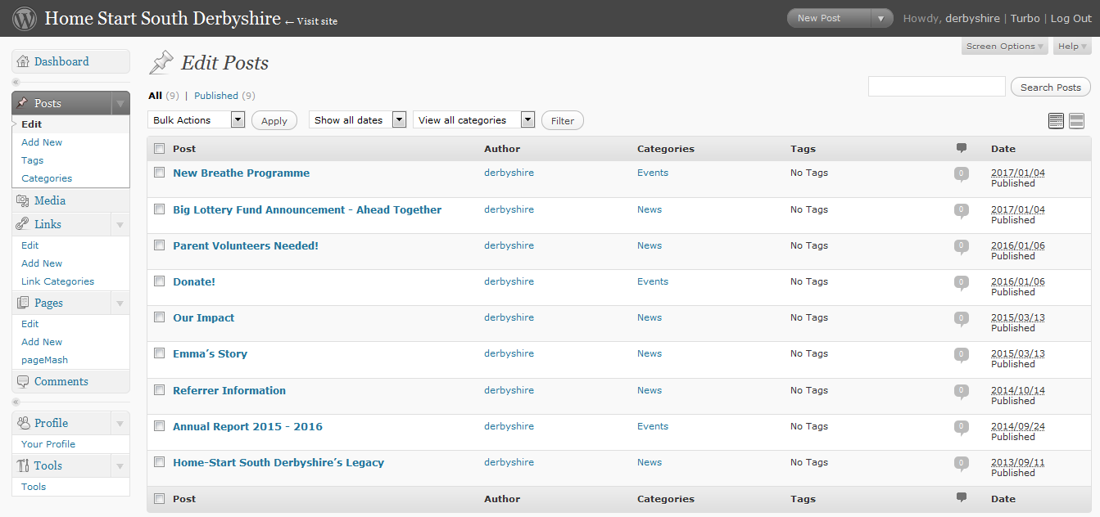

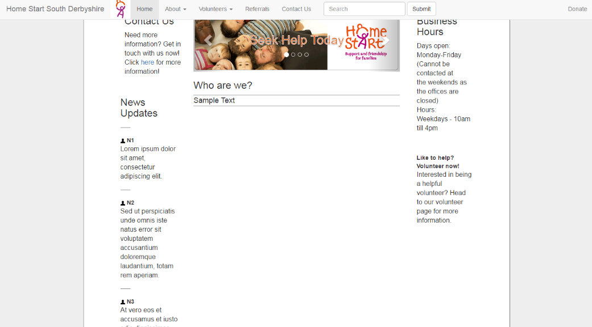

Relevant Test: 17, 18 & 19

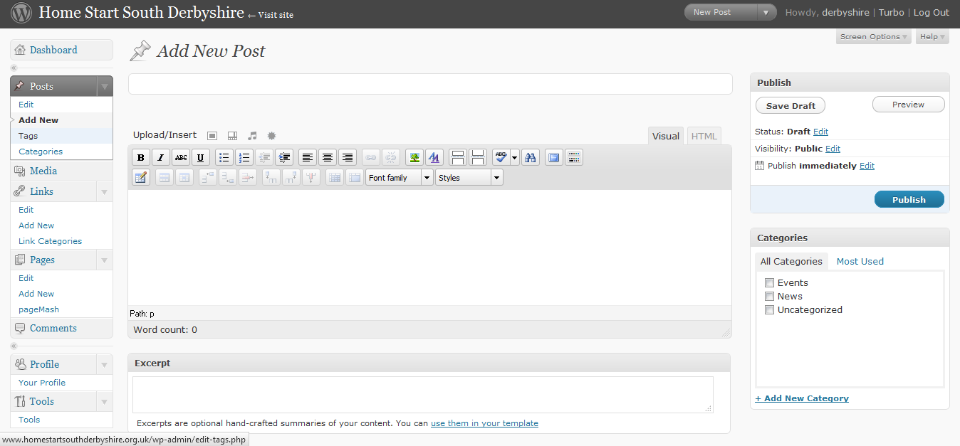

Relevant Test: 2-15

Relevant Test: 17,18 & 19

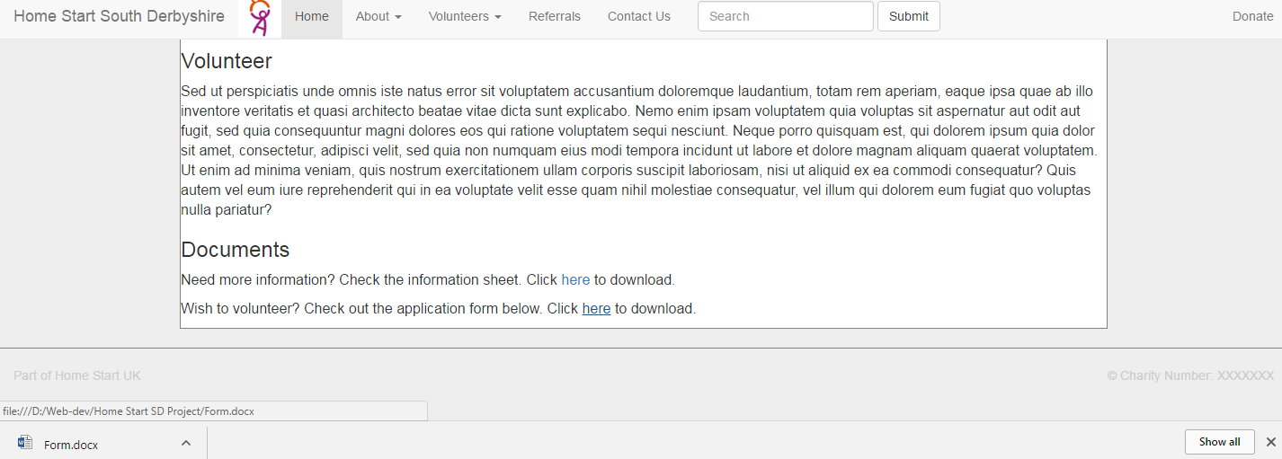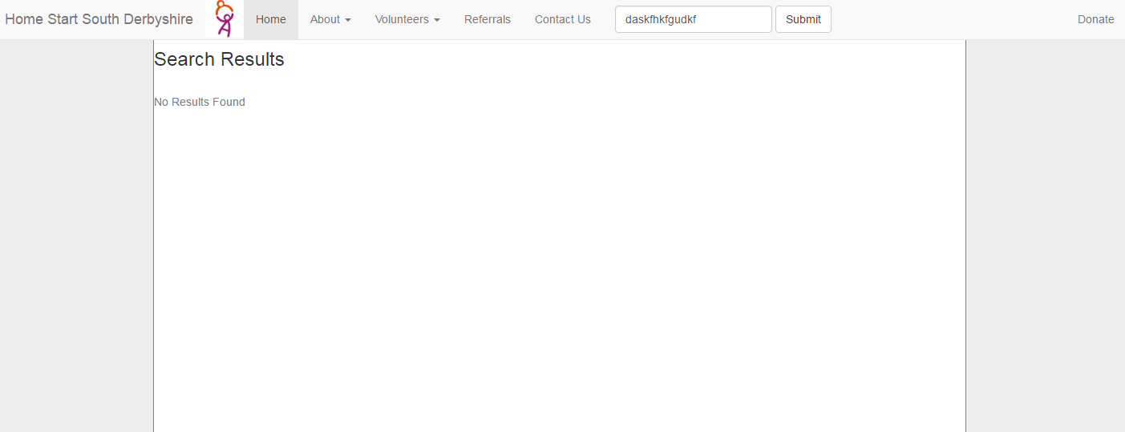

Relevant Test: 16

Relevant Test: 28,29 & 30

### 4.2 Environment & End-User Testing Plan

**Environment Testing**

**Hardware**

CPU – Intel Pentium T4300 Dual Core 64but (Clocked at 2.10GHz)

Memory – 4Gb DDR3 RAM

Storage – WDC WD5000EV-22ZAT0 ATA Hard Drive (453 Gb Maximum Capacity)

**Software**

Operating System – Windows 7 Home Premium 64bit

Primary Web Browser – Mozilla Firefox (Latest Version)

**Testing checklist**

1. Is the hardware compatible with the solution?

[ Y / N ]

1. Is the software compatible with the solution?

[ Y / N ]

1. Can the back-end be accessed and run correctly?

[ Y / N ]

1. Is the solution compatible with the designated server?

[ Y / N ]

1. Can the solution be accessed over the Internet?

[ Y / N ]

1. Does the server run consistently?

[ Y / N ]

1. Is the back-end consistently operational?

[ Y / N ]

1. Does the back-end actively update the website when changes are made?

[ Y / N ]

**User Testing**

Website Questions

1. Is the layout of each webpage to the standard you expect? If not, explain why.

1. Is the theme and house style suitable and up to expected standards? If not, explain why.
2. Are the images on the website acceptable or would you wish for them to be changed?
3. Is the static text on pages such as “About” acceptable in formatting and content?
4. Is the scripted content such as the image gallery functioning up to standard?
5. Does dynamic news and other content load and display correctly and is it up to expected standard?
6. Is the navigation bar suitable in design? If not, explain why.
7. Are pages on the website accessible easily through the navigation bar? If not, explain why.
8. Are downloads for volunteer resources easily accessible and do they initiate?

Back-End Questions

1. Are you able to access the back-end for the website? If not, explain why.
2. Is the interface simple to use and up to expected standard? If not, explain why.
3. When you update the content in the backend, does the website update correctly?
4. Are you capable of getting images to be added into the website?

User Guide Questions

1. Is the user guide simple and easy to get insight into using the system from? If not, explain why.
2. Does the system correctly explain to you how to access and use the system? If not, explain why.
3. How useful is the troubleshooting section to you?
4. Overall, how would you rate the user guide and why?

**Testing sign off:**



# Evaluation

Having reached the end of this project of designing and implementing a specialised web-based solution for my client Tracey Harris of Home Start South Derbyshire, it is time to review it as a whole. Here, I seek to draw out the critical points of success and failure within my solution and myself for this project, so future developments can improve both further.

**System**

Comparing against the 12 sections of my user requirements for the system, I would say that this has mostly been met by the solution I have created. The system will accept needed inputs and process it to give the correct output within the predicted boundaries. The only issue here was the lack of complexity in processing and outputting for the search function on the website, which unfortunately lacked interchangeable filters. Despite this storage needs, user friendliness and ease of navigation were perfectly met, as validated during user feedback. The solution’s search function was capable of using validation to reduce error and locate saved post, as according to the corresponding requirement. Hardware and software/system associated with the system were fully compatible, something discerned from my environment and user testing. In the end security, maintenance and training were all met as I compiled the correct resources in the end. However, there was an issue with security and maintenance in the form of the original back-end interface Concrete5 not working properly. This was amended using WordPress, which made the system much simpler and easier to use, further meeting the user requirements. The only flaw here was that the interface was outdated and did not allow for certain page content to be changed or updated easily.

Looking at the evaluation criteria for a comparison, the majority was met, but it is easiest to look at the results on the table here:

**Qualitative Criteria**

|  |  |  |  |  |  |  |
| --- | --- | --- | --- | --- | --- | --- |
| **No.** | **Criteria** | **User Req.** | **Criteria Met?** | | | **How it Checks Against User Requirements** |
| 1 | Has the location of the downloadable files from the previous website been improved, so that it is much easier for users to find them? | **4** | **Yes** | **No** | **Part.** | Used to see if the system has been structurally overhauled, so accessing stored files is easier. |
| 2 | Is the system presented in a new layout that looks professional and is much more user friendly? | **5** | **Yes** | **No** | **Part.** | Checks that the website meets the requirement of having a more user friendly layout, that isn’t confusing. |
| 3 | Is locating information on the website easier than it was with the previous website? | **5/6** | **Yes** | **No** | **Part.** | Checks to see if the new website has a layout that makes the overall process of finding different pieces of information about Home Start easier. |
| 4 | Has the navigation on the site been overhauled appropriately, so users can find pages easily? | **6** | **Yes** | **No** | **Part.** | Ensures that the changes to the navigation has made accessing web pages easier. |
| 5 | Can the login system for the back-end of the site check if logins are acceptable and can it use this to lock people out? | **7/**  **10** | **Yes** | **No** | **Part.** | Makes sure that the login system is capable of using validation and verification to make sure logins are valid and also uses this to keep unauthorised users out. |
| 6 | Does the back-end interface allow for the editing of suitable content on the website, a feature not available to the previous website? | **11** | **Yes** | **No** | **Part.** | Used to see if the back-end interface is able to fulfil my client’s specification of being able to edit certain parts of the website’s visual content. |
| 7 | Is there helpful features such as tooltips included with the back-end interface that build upon other training? | **12** | **Yes** | **No** | **Part.** | Checks that appropriate measures are in place to provide some extra help to users after the system has be implemented. |
| 8 | Is the overall system kept more secure than the previous, through better hosts, security and passwords? | **10** | **Yes** | **No** | **Part.** | Ensures that the entire solution has been secured properly, with necessary security features. |

**Quantitative Criteria**

|  |  |  |  |  |  |  |
| --- | --- | --- | --- | --- | --- | --- |
| **No.** | **Criteria** | **User Req.** | **Criteria Met?** | | | **How it Checks Against User Requirements** |
| 9 | Is the system able to accept click-based inputs? | **1** | **Yes** | **No** | **Part.** | Checks whether or not the system is able to accept the correct inputs from click-based interactions |
| 10 | Is the search bar able to accept character inputs? | **1** | **Yes** | **No** | **Part.** | Checks whether not the system can accept suitable character input in the fixed field. |
| 11 | Can the system respond correctly to corresponding mouse clicks? | **3** | **Yes** | **No** | **Part.** | Makes sure that the website correctly processes and outputs what corresponds to mouse interactions on interactive content. |
| 12 | Do queries produce correct results? | **3** | **Yes** | **No** | **Part.** | Ensures that the search bar queries correctly verify information in the database to produce the correct output. |
| 13 | Is the back-end of the website protected with a secure password? | **10** | **Yes** | **No** | **Part.** | Checks that the website login is suitably protected with a password for users, to keep unauthorised people out. |
| 14 | Does the system meet the minimum hardware requirements specified? | **8** | **Yes** | **No** | **Part.** | Checks that my system is capable of being run effectively on the specified minimum hardware. |
| 15 | Can the system run on the existing hardware at Home Start? | **8** | **Yes** | **No** | **Part.** | Done to make sure that the website solution’s interface can be run on the existing computer systems at Home Start, as they may not align with the minimum requirements. |
| 16 | Is the system fully compatible with the software requirements? | **9** | **Yes** | **No** | **Part.** | Checks that my website is fully compatible with all specified software. |
| 17 | Does the back-end interface function properly? | **11** | **Yes** | **No** | **Part.** | Ensures that the back-end interface is able to start and connect with the website. |
| 18 | Does the back-end interface feature an interface that is as simple to use as the website? | **11** | **Yes** | **No** | **Part.** | Checks that the interface is suitable and simple, so it is easier for client use. |
| 19 | Can the back-end interface edit suitable content on pages, including articles, as well as archive old content? | **11** | **Yes** | **No** | **Part.** | Makes sure that the interface meets its specified purposes, being able to complete all of them. |
| 20 | Is the overall system designed so that as little training as possible is needed to use it? | **12** | **Yes** | **No** | **Part.** | Checks that the system has been made so that it can be as simple to understand as possible, to make users capable of using it with as little aid as possible |
| 21 | Is a backup copy of the system and all of its files kept in place and updating at least once a week? | **10/**  **11** | **Yes** | **No** | **Part.** | Ensures that there are appropriate measures in place to keep backups of the website and its files to make sure they are not lost in the event of a disaster. |

From having gone through the criteria, it can be seen that I have mostly met the set criteria for this solution, which shows that I have at least matched what I intended to produce. However, this mainly evaluates it from a functional point of view, and not a user’s, which I will go into much deeper detail for.Looking at the solution as a whole, I can evaluate it by core strengths and weaknesses to ultimately decide what can be improved upon in the future, for this solution and others. I will simply run through the key points that defined the solution

**Strengths:**

* The website features interchangeable page content, so that the user can customise it without external help.
* Features a simple back-end interface that enables the user of the website solution to post, edit, sort and delete new or old content to the site.
* The solution is highly compatible with hardware and software, making it widely available for use without needing changes.
* The system is secured with a logon system to keep it protected.
* Users can easily locate and access content on the website, such as files to download and images, as found from end user testing.
* Well-constructed documentation and user guide provided to help the user, which was tested to ensure that it was perfect.
* A wide variety of media, such as videos and images can be added to the website by the user.

**Weaknesses:**

* Not all features on the website can be changed out, such as the navigation bar and other elements on the page.
* The system for articles does not have a separated archive, as only active articles can be viewed. Deleted and archived articles are stored internally.
* The back-end is not fully up to date due to development constraints, which can pose a security risk that violates the user requirements.

**Improvements:**

* Create an up to date and improved back-end that allows all functions initially proposed in cooperation with the client.
* Enable the website to be fully customisable, with all elements interchangeable.
* Improve systems for storing posts and articles on a website, so that they can be searched for with greater specifications.
* Make the user interface even more user-friendly with features such as tooltips and guides provided within the software itself.

From having looked at these key points, it can still be concluded that my overall solution was a success, as it met its key functions and testing revealed that my client was happy in the end. However, it does still stand that it fell short in some areas and thus, I must take these into account as guidelines to improve for similar solutions in the future.

**Self-Evaluation**

It is now that I move onto evaluating myself, the creator of the solution who handled the proposed scenario from my client. It is important that I go through this, so that I can look at how I handled things to see what was good and what was not. I can also look into how I may have improved and how I can improve in the future. From this, I hope I will see how to improve myself for another project of a similar nature.

Starting off, I carried out this project with great resilience in order to complete it and the large volume of required documentation. Despite many challenges and issues encountered along the way, I made it to the very end where I have a completed solution that my client is satisfied with. I also kept up communication with my client, keeping in touch frequently. This made it easy to get them involved where necessary to help complete needed documentation and testing. I would also say that I demonstrated a good use of technical skills to create my solution, where originally the website was mostly custom coded by me and then implemented within WordPress. Whilst this presented some technical difficulties and limitations, I still used skill to complete the solution. Linking in with that, I also showed that I was capable of adapting to changes spurred on by issues. The issue in question was the mandatory switch I made from Concrete5 to WordPress, which I handled well in the end, as I made a successful switch that made a system that worked even better than anticipated.

However, whilst there are successes, there are also failures and I had a lot of them. The main one here being my organisational skills and time management. I was consistently poor with this and often missed deadlines for certain tasks as I did not adhere to my Gantt chart and other planning. At times, certain tasks were all over the place breaking the planned sequence of work, leaving holes at times. My response to client feedback was also quite limited as I often met their expected standards from the start, so I often left small details for improvement out, only to notice much later or not at all. Admittedly, my handling of workload was also poor, as my lack of organisation made the handling of work unbearable a times. Whilst tasks were completed in the end, this does not reflect well in my performance.

These strengths and weaknesses were distributed across each of the sections that I completed across the past year. By the start in section 1, I was adhering to deadlines and remaining diligent consistently. However, by section 2 this had begun to decrease with this trend carrying on with each section. Despite a good point of myself being resilient in finishing, my rate of completing work had massively decreased by section 4, where deadlines were consistently missed, with a backlog of work. This happened as there was a learning curve in being able handle the work that I would go through. Admittedly, I was completely new to handling this level and quantity of documentation in relation to a project involving ICT skills. Whilst I have done projects in the past, they were either pure technical practice or much smaller, so this was incomparable. Thus, I believe that this learning curve I went through, was responsible for making me unable to cope and manage the workload. Whilst I was never able to fully recover from this issue which got worse with each section, I can say that it has prepared me to face larger projects in the future and has given me greater knowledge on how to handle this level of documentation.

With all of this though, I must say that I feel as though my skills in web development have improved since the start, due to the fact that I had to work hard to produce a fully integrated system that matched my initial level of skill in difficulty. My skills in documentation and so on for such projects has increased as well though. Whilst, technical skills are an obvious improvement, the fact that I had to go through so much documentation has given me a skill boost in how to handle and how to write it.

If I were take what I have I found to improve myself, then it is clear that in the future I should be more careful and rigorous with planning and time management. I should strictly follow plans that I have laid out so I can meet deadlines much better next. This would also improve the overall quality of a project as I would allocate more time to each task in order, so it pieces together much better.

**Conclusion**

To draw everything to a close, I have looked through this project as a whole, myself included and have looked at what was good, bad and what I can do to change that. I have found the key areas of myself that should change for another project from evaluating my performance and the solution that I created. It is my hope that I can take what I have found here and apply it in the future to produce work that surpasses what I have made here. Overall though, I would say that this solution was a complete success that met the majority of its criteria and requirements and even smashed them.